

**Department of Biochemistry Government Medical College Bhavnagar**

Certificate of Completion

**Name of Student :**

**Roll Number:**

**Year of Admission:**

**Remarks:**

|  |  |
| --- | --- |
| **Teacher Department of Biochemistry Government Medical College**  **Bhavnagar** | **Professor and Head Department of Biochemistry Government Medical College**  **Bhavnagar** |

**I N D E X**

|  |  |  |  |
| --- | --- | --- | --- |
| **No** | **Exercise** | **Date** | **Signature of**  **Teacher** |
| 1 | Commonly used laboratory apparatus and equipment, good safe laboratory practice and biomedical waste  management (BI 11.1) |  |  |
| 2 | Chemical components of normal urine. (BI 11.3 &  BI11.4) |  |  |
| 3 | Abnormal constituents of Urine and its clinical  importance (BI 11.20, BI11.4) |  |  |
| 4 | Composition of CSF(BI11.15) |  |  |
| 5 | Principles of colorimetry and spectrophotometry  (BI11.6, BI11.18 & BI11.19 ) |  |  |
| 6 | Estimation of Plasma glucose (BI11.21) |  |  |
| 7 | Oral Glucose Tolerance Test |  |  |
| 8 | Demonstrate estimation of serum creatinine and  calculate creatinine clearance (BI 11.7 and BI 11.22) |  |  |
| 9 | Estimation of serum urea (BI11.21) |  |  |
| 10 | Estimation of serum Total Proteins (BI 11.21) |  |  |
| 11 | Estimation of serum albumin and calculate A:G ratio  (BI 11.8 and BI 11.22) |  |  |
| 12 | Estimation of serum Bilirubin (BI11.12) |  |  |
| 13 | Estimation of serum SGPT (BI11.13) |  |  |
| 14 | Estimation of serum SGOT (BI11.13) |  |  |
| 15 | Estimation of serum alkaline phosphatase (BI11.14) |  |  |
| 16 | Estimation of serum Total cholesterol (B  I 11.9) |  |  |
| 17 | Estimation of serum Triglyceride (BI 11.10) |  |  |
| 18 | Estimation of serum HDL Cholesterol (BI 11.9) |  |  |
| 19 | Estimation of serum calcium (BI11.11) |  |  |
| 20 | Estimation of serum Phosphorus (BI11.11) |  |  |
| 21 | Preparation of buffers and estimation of pH.(BI11.2) |  |  |
| 22 | Arterial Blood Gas Analysis (BI11.16) |  |  |
| 23 | Chromatography (BI11.16 and BI11.19 ) |  |  |

|  |  |  |  |
| --- | --- | --- | --- |
| 24 | Electrophoresis (BI11.16 and BI11.19) |  |  |
| 25 | ELISA (BI11.16 and BI11.19 ) |  |  |
| 26 | Screening of urine for inborn errors. (BI11.5) |  |  |
| 27 | Autoanalyzer |  |  |
| 28 | Quality control (BI11.16) |  |  |
| 29 | Calculate energy content of different food Items, identify food items with high and low glycemic index  and explain the importance of these in the diet (BI11.23) |  |  |
| 30 | Discussion on advantages and/or disadvantages of use of unsaturated, saturated and trans fats in food  (BI11.24) |  |  |
| 31 | Case Study of Gout (BI11.17) |  |  |
| 32 | Case Study of Diabetes Ketoacidosis (BI11.17) |  |  |
| 33 | Case Study of Diabetes mellitus (BI11.17) |  |  |
| 34 | Case Study of Myocardial infarction (BI11.17) |  |  |
| 35 | Case Study of Myocardial infarction (BI11.17) |  |  |
| 36 | Case Study of CRF (BI11.17) |  |  |
| 37 | Case study of Sickle cell anemia |  |  |
| 38 | Case study of Thalassemia |  |  |
| 39 | Case Study of Glycogen storage disease |  |  |
| 40 | Case Study of Portal Hypertension |  |  |
| 41 | Case study of Jaundice (BI11.17) |  |  |
| 42 | Case Study of Thyroid dysfunction (BI11.17) |  |  |
| 43 | Case Study of Porphyria |  |  |
| 44 | Case Study of Anemia |  |  |
| 45 | Case Study of Nephrotic syndrome, Proteinuria, Edema  (BI11.17) |  |  |
| 46 | Case Study of Pancreatitis (BI11.17) |  |  |

|  |  |  |  |  |
| --- | --- | --- | --- | --- |
| 47 | Topic distribution Among Paper 1 & 2 for  Preliminary & University examination |  |  |  |
| 48 | First Year M.B.B.S. Internal, Preliminary &  University Theory Examination Paper style |  |  |  |
| 49 | List of Model short questions |  |  |  |
| 50 | List of Model Justifications |  |  |  |

1. **Commonly used laboratory apparatus and equipment, good safe laboratory practice and waste disposal. (BI 11.1)**

## What will I learn in biochemistry practical?

1. Study of properties of basic biomolecules. e.g. Carbohydrate, Proteins, lipids
2. Study of various instruments and apparatus used in biochemistry and their principles. e.g colorimeter, semi-automatic analyzer, ELISA reader chromatography, electrophoresis, point-of-care-testing **(POCT)** etc.
3. Study of patient case - history - laboratory investigations in context to understand clinical aspects of biochemistry.
4. What are various types of laboratory hazards?
5. What is biomedical waste and how should it be disposed of safely?

**Commonly used laboratory apparatus and equipment**

1. **Colorimeter**

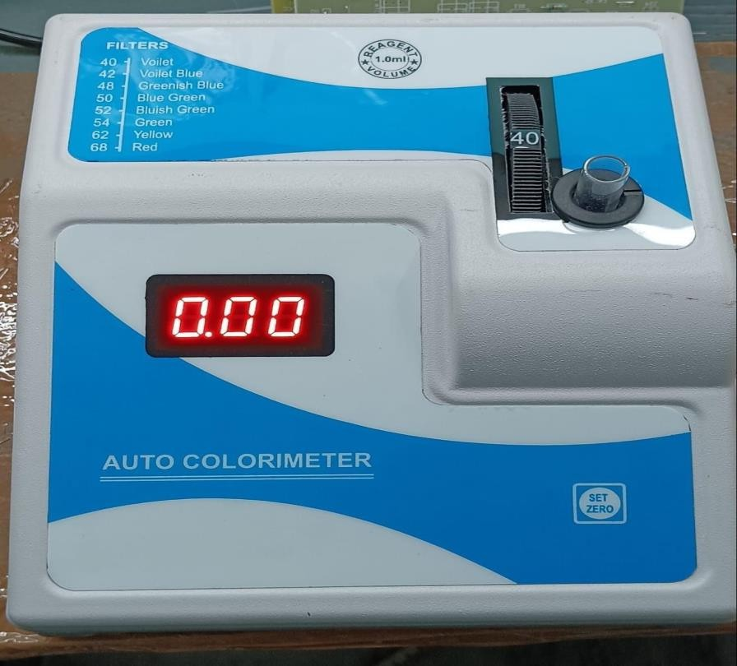

1. 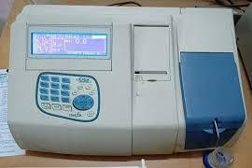**Semi Auto analyzer**
2. 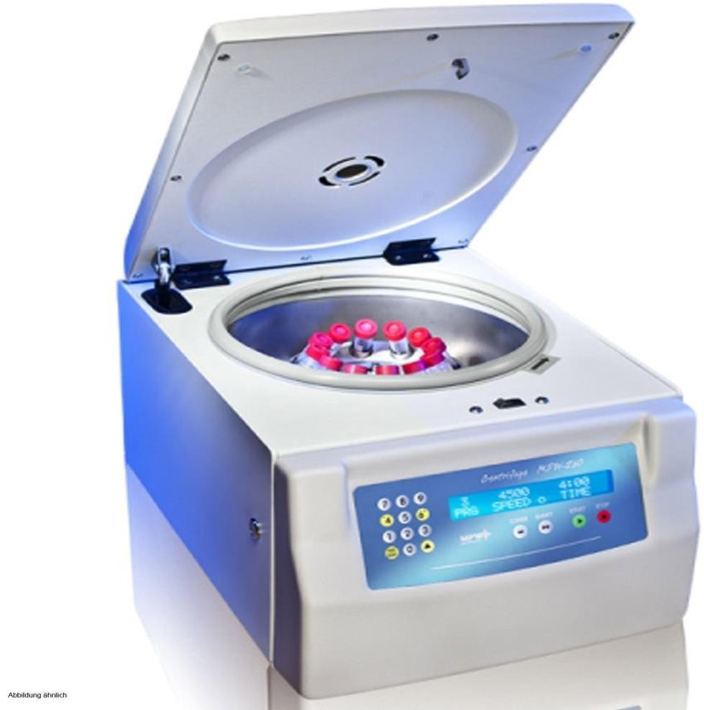**Centrifuge**
3. 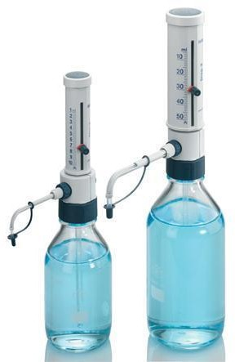**Auto Dispensers**
4. **Pipette**

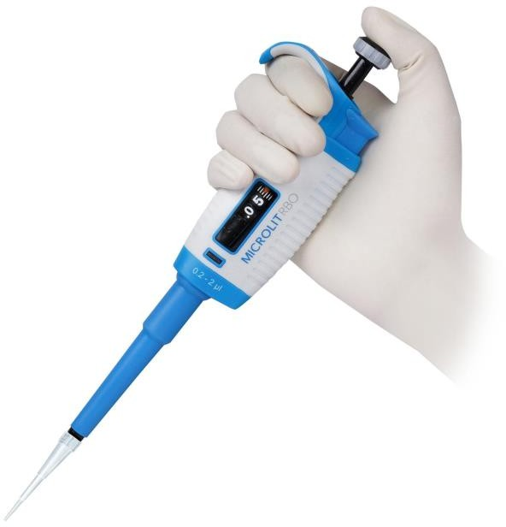

**Hazards in the biochemistry lab**

The laboratory hazards fall into three main categories: chemical hazards, biological hazards, and physical hazards.

* 1. **Chemical hazards:** Chemical Injury results from
     1. Direct contact with skin, lips or mouth while pipetting, with esophagus and stomach if inadvertently swallowed.
     2. Damage to lungs from inhalation of vapors.
     3. Toxic effects of substances absorbed from lungs, alimentary tract, or skin on other tissue such as bone marrow, lungs, liver, kidney etc.
  2. **Biological hazards:** Biological hazards involve exposures to infectious samples, animal diseases transmissible to humans, and biological agents used during experimental procedures that include viral vectors, etc.
  3. **Physical hazards:** physical hazards may occur due to accidental spill of corrosive reagent, broken glassware, etc.

## Precautions to be taken while doing biochemistry practical

1. Wear an apron and tie hair during practical.
2. Never do mouth pipetting to take reagents.
3. While heating, keep your test tube away from your body.
4. Do not use any concentrated acids and alkaline solutions like concentrated HCl , NaOH, H2SO4, HNO3.
5. Do not handle any chemical directly. Use pipette, Spatula etc.
6. Turn off the gas burner after completing practical.
7. Safe disposal of biomedical waste

## Accidents in lab and first aid for them

|  |  |  |
| --- | --- | --- |
| **Sr No.** | **Injury/ accident** | **First aid** |
| 1 | Alkali splash on the skin | Wash with tap water for 15 min followed by  5% acetic acid solution |
| 2 | Acid splash on the  Skin | Wash with tap water for 15 min followed by  5% sodium carbonate solution |
| 3 | Phenol burn | Wash with plenty of tap water. Then use  polyethylene glycol with water |
| 4 | Splashes in the  Eyes | Wash with plenty of tap water and sterile  saline. Then seek doctor’s help |
| 5 | Injury due to broken glass | Wash wounds immediately with disinfectant |
| 6 | Burn | Wash with plenty of tap water and cover with  sterile dressing |

**Biomedical waste and its management**

**Definition:** Biomedical waste is defined as any waste, which is generated during the diagnosis, treatment or immunization of human beings or animals, or in research activities.

## Categories of Biomedical Waste

1. Human anatomical waste: (tissues, organs, body parts)
2. Animal waste: (including animals used in research and waste originating from veterinary hospitals and animal houses).
3. Microbiological and biotechnology waste: (including waste from lab cultures, stocks or specimens of microorganisms, live or attenuated vaccines, wastes from production of biologicals, etc.)
4. Waste sharps: (used/unused needles, syringes, lancets, scalpels, blades, glass etc.)
5. Discarded medicines and cytotoxic drugs.
6. Soiled wastes: (items contaminated with blood and body fluids, including cotton dressings, linen, plaster casts, bedding etc.)
7. Solid wastes: (wastes generated from disposable items other than waste sharps such as tubing, catheters, i.v. sets, etc.)
8. Chemical waste: (waste generated from washing, cleaning, house- keeping and disinfection activities including these activities in labs).

Medical waste is unwanted biological products that are highly infectious in nature. It has to be disposed of properly otherwise it poses a health and environmental danger.

## Need of biomedical waste management in hospitals

The reasons due to which there is great need of management of hospitals waste such as:

* + Injuries from sharps leading to infection to all categories of hospital personnel and waste handlers.
  + Nosocomial infections in patients from poor infection control practices and poor waste management.
  + Risk of infection outside the hospital for waste handlers and scavengers and sometimes public living in the vicinity of hospitals.
  + Risk associated with hazardous chemicals, drugs to persons handling wastes.
  + “Disposable” being repacked and sold by unscrupulous elements without even being washed.
  + Drugs which have been disposed of, being repacked and sold off to unsuspecting buyers.
  + Risk of air, water and soil pollution directly due to waste, or due to defective incineration emissions and ash.

## Biomedical Waste Management Process

Following are the steps of biomedical waste management.

* + Waste collection
  + Segregation
  + Storage
  + Treatment
  + Transport to final disposal site
  + Final disposal

## Questions

* + 1. What precautions should be taken while working in a laboratory?
    2. What are the hazards of unsafe disposal of biomedical waste?
    3. How biomedical waste is segregated?
    4. Enlist 10 chemicals used in your lab that can cause accidents. What first aid should be given to victims of those accidents?

**Color codes for segregation of biomedical waste and method of disposal**

|  |  |  |
| --- | --- | --- |
| **Category** | **Type of waste** | **Treatment/Disposal options** |
| Yellow | Covid request form Cap  Face mask Gauge piece Glucometer strip Blood bag  QC material Reagent Vaccines Expired drugs | Incineration or plasma pyrolysis or deep burial |
| Red | Contaminated waste (Recyclable) Gloves  Tips  Reagent bottles Syringe  IV set, Tubing Vacuette Eppendorf cups Plastic goggles | Auto/Micro/Hydro & then sent for recycling. |
| White puncture proof container | Needle Scalpel | Auto or Dry Heat sterilization followed by shredding or mutilation or encapsulation |
| Blue | Broken glassware Glass test tube Beaker  Metallic implants | Disinfection or auto/micro/hydro & then sent for recycling |
| Green | Normal request form Paper of gloves Food wastage  Water bottle | Incineration or plasma pyrolysis or deep burial |

1. **Physical & Chemical components of normal urine. (BI11.3 & BI11.4) Physical characteristics of normal urine**

|  |  |  |
| --- | --- | --- |
| **Features** | **Characteristics** | **Reason** |
| **Volume** | 800-2500 ml/day Average output: 1500ml/day | According to quantity of food & fluid ingested, water produced by oxidation of food stuff Environment temperature,  Physical activity,  Loss of water in feces, via skin, via respiratory tract etc. |
| **Appearance** | fresh sample- clear and transparent | On standing bacterial urease converts urea into CO2 and Ammonia. Ammonia makes urine alkaline. Phosphates, Oxalates and urates  precipitate in alkaline urine making it turbid. |
| **Color** | fresh sample-  Amber yellow. | This color is due to the presence of pigment  urobilin. |
| **Odour** | Aromatic odor | Odor due to the presence of volatile organic acids produced by body and intestinal bacteria.  On standing, urine gives ammoniacal smell due to  conversion of urine urea into ammonia by bacterial action. |
| **pH** | Range (4.8 – 7.5)  Average 6.0 (Acidic) | 1. Post-prandial urine is alkaline due to secretion of HCl in the stomach, the condition known as “Alkaline tide”.   H2CO3→H+ + HCO3- H+ + cl- →HCL   1. Protein diet makes urine more acidic. Metabolism of protein produces sulfuric and phosphoric acid excretion of these acids makes the urine acidic. 2. Diet rich in vegetables and fruits makes urine more alkaline. Citric acid & tartaric acid present in fruit & vegetables are converted to bicarbonate to make urine alkaline 3. Standing urine becomes alkaline due to ammonia formation. |
| **Specific gravity:** | 1.012-1.024 | Fluid intake and Specific gravity have reciprocal relationships. The greater the amount of solute per unit volume of urine, the specific gravity will be greater. |

**Physiological significance**

|  |  |  |  |
| --- | --- | --- | --- |
| rameter | Significance | Increased excretion | Decreased  excretion |
| Urea | End product of protein catabolism. Liver is the site of urea production. | High protein diet, increased tissue catabolism, fever, Diabetes mellitus | Liver malfunction, Nephritis, Acidosis |
| Uric acid | End product of Purine catabolism | Increased tissue metabolism such as Leukemia, Anticancer drug therapy | Renal failure |
| Creatinine | End product of muscle Creatine Phosphate, which is derived from  Glycine, Arginine & Methionine | High intake of meat & fish, myopathy, muscle wasting disease, fever | Renal failure, Paralysis |
| Ammonia | Urinary Ammonia is derived from Glutamine amino acid  in the renal tubular cells. | Acidosis, impaired protein catabolism | Alkalosis |
| Chloride | Chief Anion excreted as a Sodium Chloride | Sweating, Fasting, Diarrhea & Vomiting, Addison disease, use of  Diuretics | Edematous condition, Diabetes  insipidus |
| Sulphate | Organic, Inorganic and neutral sulfates are derived from metabolism of sulfur containing amino  acids | High protein diet, Cystinuria, Homocystinuria, increased tissue breakdown | Renal dysfunction |
| Phosphates | Urinary phosphate is derived from breakdown of phospholipids, phosphoprotein and  nucleotides | rickets, osteomalacia, hyperparathyroidism, Acidosis | Nephritis, Diarrhea, Pregnancy |
| Calcium |  | Renal stone, Hypervitaminosis D,  Multiple Myeloma, Renal |  |

|  |  |  |  |
| --- | --- | --- | --- |
|  |  | tubular acidosis,  Diuretics, |  |

**Collection of urine to measure volume**

Discard the first morning urine. Then collect urine during each micturition in a vessel up to, including the next morning urine.

**Specific gravity measurement by urinometer:**

Specific gravity is used to determine mass (weight) of solution. It relates the weight of 1 ml of solution and weight of an equal volume of pure water at 4°CThe greater the amount of solutes per unit volume of urine, the greater the specific gravity.

1. How to measure the specific gravity of urine?

A 100 ml measuring Cylinder is filled with urine to about 3/4 th of its length. The Urinometer is placed gently into the urine. Allow it to dip. However, it should not touch the walls of the cylinder. This Instrument floats in the Urine.

## Calculation

Suppose the meniscus of the urine coincides with the reading 1.015; it corresponds to the specific gravity 1.015. But the urinometer is calibrated for use at a temperature of 15°C; Hence, the specific gravity should be corrected to room temperature which may be above or below 15°C at which the urinometer was calibrated.

Temperature correction: 0.001 is to be added for every 3°C above and 0.001 is to be deducted for every 3°C below in the temperature at which the urinometer is calibrated (15° C). Suppose the reading coincides with 1.015, it will be corrected to room temperature as follows. The difference between room temperature 37 and 15" (calibrated temperature) is 22°C. This, when divided by 3 gives 7. So, the corrected specific gravity=1.015+ (7x0.001) =1.022.

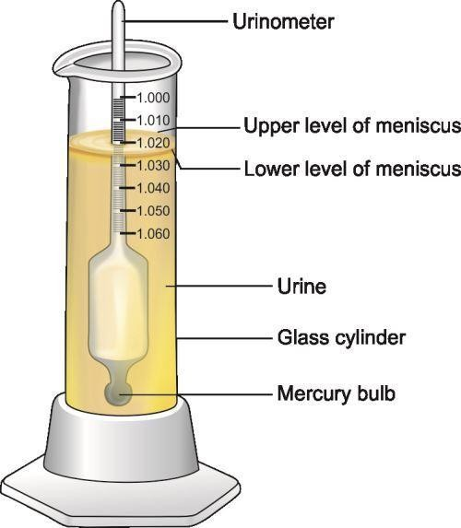

## Constituents of normal urine

|  |  |  |  |
| --- | --- | --- | --- |
| **Nitrogenous** | | **Non Nitrogenous** | |
| Urea | 25-30 g/day | Inorganic Sulfate | 0.6-1.8 g/day |
| Uric Acid | 0.5-0.8 g/day | Phosphate | 0.8-1.3 g/day |
| Creatinine | 1.0-1.5 g/day | Chloride | 10-15 g/day |
| Ammonia | 0.7- 0.8 g/day | Sulphate | 0.06 to0.2 g/day |

**Chemical analysis of urine**

1. **Nitrogenous Constituents**

|  |  |  |  |
| --- | --- | --- | --- |
| **Procedure** | **Principle** | **Observation** | **Inferenc**  **e** |
| **Test for Urea- Specific Urease Test** | | | |
| [2 ml Urine] + [2 drops phenolphthalein]. Add Urease powder, mix. | Urea Urease NH3 + CO2 CO2 evaporates.  In this reaction the liberation of NH3 changes the pH to alkaline side, turning phenolphthalein to pink color. | Pink color formation is seen | Urea is present |

|  |  |  |  |
| --- | --- | --- | --- |
| **Test for Uric acid- Phosphotungstic acid reduction test/ Carryway’s Test** | | | |
| To 2 ml of urine + 2 ml of Uric acid reagent + 3-4 drops of 10% NaOH | Uric acid is a reducing agent in alkaline medium. It reduced  Phosphotungstic acid into tungsten blue. | Deep blue color develops | Uric acid present |
| **Test for creatinine- Jaffe’s test** | | | |
| 1 ml alkaline picrate solution  + 2 ml of urine + 3-4 drops of 10% NaOH | Creatinine forms creatinine picrate in alkaline medium which is orange in color. | Orange color develops | Creatinin e present |
| **Test for ammonia** | | | |
| 2 ml of urine and 3 ml of 10% NAOH. Boil the content and allow Vapors to come out. Hold the filter paper containing a drop of phenolphthalein just above the test tube. | On heating NH3 evaporates, which is alkaline in nature. Phenolphthalein is a weak  acid, which can lose H+ ions in solution. The phenolphthalein molecule (HIn) is colorless, and the phenolphthalein ion(In-) is pink. When a base is added to the phenolphthalein, the molecule ⇌ions equilibrium shifts to the right, leading to more ionization as H+ ions are removed.  HIn → H+ + In-  For phenolphthalein: pH 8.2 = colorless; pH 10 = red | Filter paper turns pink. | Ammonia is present. |

1. **Inorganic Chemical constituents**

|  |  |  |  |
| --- | --- | --- | --- |
| **Procedure** | **Principle** | **Observation** | **Inferenc e** |

|  |  |  |  |
| --- | --- | --- | --- |
| **Test for chloride** | | | |
| * [2 ml of urine] +[0.5 ml   concentrated HNO3] + [0.5ml 3% AgNO3]   * (Concentrated HNO3 is added to prevent   precipitation of urate and acid phosphates by  AgNO3) | AgNO3(aq) + NaCl(aq) → AgCl(s) + NaNO3(aq) When acidified urine reacts with silver nitrate, a white precipitate of silver chloride is formed. | Curdy white precipitate of AgCl is formed. | Chloride is conforme d. |
| **Test for Phosphate** | | | |
| * [1 ml of urine] + [0.5ml   concentrated HNO3] + [1ml of 5% Ammonium molybdate], Heat the test tube. | Inorganic phosphorus reacts with ammonium molybdate in an acidic medium to form a phosphomolybdate complex. | Canary yellow precipitate of Ammonium phosphorus molybdate are  formed | Phosphat e is conforme d |
|  | | | |
| **Test for Calcium** | | | |
| To 0.5 ml urine and add 1 drop of saturated ammonium oxalate solution. | CaCl2(aq) + (NH4)2C2O4(aq) → CaC2O4(s) + 2 NH4Cl(aq) | Calcium precipitated as insoluble calcium oxalate is observed as  turbidity. | Calcium is present |
| **Test for Sulphate** | | | |
| [1ml urine] + [3 drops 1% diluted HCL] + [ 6 drops of 10% Barium chloride]. | HCl  SO4-2 + 2BaCl2 →  Ba2SO4 + KCL | White precipitates of Ba2SO4 are formed. | Sulfur is present |

**QUESTIONS**

* 1. What is alkaline tide? Is it a Pathological Condition?
  2. What are the physiological factors affecting the urine volume?
  3. What are the normal inorganic constituents present in the urine?
  4. In which form inorganic sulfate is excreted in Urine?
  5. What are the organic substances excreted in Urine?
  6. Write NPN constituents of Urine.
  7. Why is uric acid excreted in Urine?
  8. Why urine samples become turbid on standing?
  9. What are the Physiological Causes of Excess Creatinine in Urine?
  10. Serum Creatinine of one patient was 6.0 mg/dl after amputation when again Serum Creatinine was done it drops to 4.0 mg/dl. What is the probable reason for this?
  11. How Hippuric acid is produced?
  12. What is the volume of normal urine output per day?
  13. What are the common causes of turbidity in a fresh urine sample?
  14. What is the pigment responsible for the normal color of urine?
  15. How is the specific gravity of urine measured?
  16. What is 'temperature correction' while reading the urinometer?
  17. Name the conditions in which large amounts of calcium are excreted in urine.
  18. Is urobilinogen normally present in urine? Name one condition where excretion of urobilinogen is increased. Name the test to identify urobilinogen.
  19. What are the compositions of various kidney stones?
  20. What are ethereal sulfates?
  21. Name the conditions in which excretion of urea in urine is increased.
  22. When is the excretion of creatinine increased?

1. **Abnormal constituents of Urine and its clinical importance Abnormal Urine**

**(BI 11.20, BI 11.4)**

**Physical Characteristics of Abnormal Urine**

|  |  |  |
| --- | --- | --- |
| **Characteristics** | **Pathological condition** | **Reason / Clinical Condition** |
| **Volume** | Polyuria (>3 L /day) | Hyperglycemia, Diabetes insipidus,  Late stages of chronic glomerulonephritis, Diuretics, Excessive alcohol intake |
| Oliguria (<400 ml/day) | Fever, Diarrhea, Vomiting,  Acute nephritis, Renal failure, Shock |
| Anuria (< 100 ml/day) | Acute tubular necrosis, Blood transfusion reaction, Surgical shock,  Bilateral renal stones |
| **Appearance** | Turbid | Infection (cells make urine turbid) |
| **Color** | Deep yellow | Hepatic jaundice & obstructive jaundice |
| Red | Hematuria,  Drugs like rifampicin, Kidney / Ureteric stone |
| Red on exposure to air | Porphyria |
| Black | Alkaptonuria, Malignant melanoma |
| Milky white | Chyluria |
| Brownish | Hemoglobinuria (Black water fever, myoglobinuria) |
| **Odor** | Stronger pungent smell | Dehydration(ammonia) |
| Fruity | Diabetic ketoacidosis (acetone) |
| Mousy | Phenylketonuria (Phenyl lactate) |
| Foul smell | Urinary tract infections (H2Setc.) |
| **pH** | Acidic if less than 4.8 | 1. Acidosis- Metabolic and Respiratory 2. Fever 3. On high protein diet 4. Uncontrolled diabetes 5. Presence of ammonium chloride |
| Alkaline more than 7.5 | 1. After meals (Alkaline Tide) 2. Diet rich in vegetables, Citrus Fruits |

|  |  |  |
| --- | --- | --- |
|  |  | 1. Renal tubular Acidosis 2. Ingestion of potassium citrate, acetazolamide, sodium bicarbonate |
| **Specific Gravity** | High specific gravity | 1. Diabetes mellitus 2. Diarrhea 3. Dehydration |
| Low specific gravity | 1. Diabetes insipidus 2. Renal failure 3. Excessive fluid intake 4. Acute tubular necrosis |
| Fixed Specific Gravity (Isosthenuria) | Condition in which Specific Gravity of urine is equal to the Glomerular Filtrate & it is around 1.010. It is seen in patients with Chronic Renal Diseases regardless of  changes in salt and water intake by the patient. |

**Chemical Characteristics of Abnormal Urine**

1. **Proteins**

**Heat coagulation Test:**

## Principle:

Proteins have net zero charge at their iso-electric pH (pI). So, at pI, protein molecules have minimum repelling force. Thus, proteins are easily precipitated at pI.

When proteins are heated, weak bonds like hydrogen-bonds, salt bonds and van-der-waal forces are broken. Proteins are said to be denatured. Core hydrophobic regions of denatured Albumin can form intermolecular associations and cause precipitation. Thus, to precipitate proteins like albumin, two conditions are required.

* 1. Bring albumin to its pI(5.4) by adding few drops of 1% acetic acid
  2. Heat the solution

**Procedure:** Fill 3/4 th of the test tube with a urine sample. Heat the upper part on the flame till either turbidity appears or urine starts boiling. Now add a few drops of 1% acetic acid if turbidity develops & note change.

In case of multiple myeloma, light chains of immunoglobulin (also called as Bence Jones proteins) precipitate between 40-60 degrees centigrade. On further heating turbidity disappears. Turbidity appears again on cooling to 40-60 degree centigrade.

**Sulphosalisylic Test:**

## Principle

Test is based on the precipitation of urine protein by a strong acid, sulfosalicylic acid. Precipitation of protein in the sample is seen as increasing turbidity. Unlike the routine urine protein chemistry dipstick pad, the SSA reaction will detect globulin and Bence- Jones proteins, in addition to albumin.

## Method:

3 ml of urine + 0.3 ml of 30% Sulphosalicylic acid, mix. Turbidity indicates the presence of urinary proteins.

## Proteinuria and albuminuria

|  |  |
| --- | --- |
| Proteinuria | |
| Normal Adult | <150 mg /day |
| Proteinuria | >=150 mg /day |
| Proteinuria (nephrotic range) | >3500 mg / day |
| **Albuminuria** | |
| Normal Adult | <30 mg /day |
| Microalbuminuria | 30-300 mg /day |
| Macroalbuminuria | >300 mg /day |

Albumin (Filtered but not reabsorbed) and Tamm-Horsfall protein (secreted by renal tubules) are normally present.

## Causes of Proteinuria:

* Pre-renal: (overload proteinuria)
  + Multiple myeloma (light chains of immunoglobulins)
  + Severe hemolysis (Hemoglobin)
  + Severe muscle injury (Myoglobinuria)
* Renal: *Glomerular diseases* (Mainly albumin, being small)
  + After streptococcal infection
  + Diabetes mellitus, Hypertension
  + Lipoid Nephrosis (Nephrotic range proteinuria)
  + Tubular diseases (decreased reabsorption of proteins)
  + Tubular necrosis due to Drugs and toxins
* Post Renal: (various blood and cellular proteins)
  + Bleeding in urinary tract
  + Infection in urinary tract
  + Tumor in urinary tract
* Other causes:
  + Postural: on standing posture.
  + Exposure to cold, physical activity, fever.
  + Last weeks of pregnancy

1. **Acetone & acetoacetic acid (Ketone Bodies):**

## Rothera’s test Principle

Acetoacetic acid and acetone form a violet-colored complex with sodium nitroprusside in alkaline medium. Acetoacetic acid reacts more sensitively than acetone. ß- hydroxybutyric acid (not a ketone) is not detected.

Sodium Nitroprusside: acetone form a violet-colored complex with sodium nitroprusside in alkaline medium

Sodium carbonate: Provides alkaline medium

Ammonium sulfate: Precipitate other protein which give purple color with sodium nitroprusside & make solution

**Procedure:**

Saturate 2 ml urine with ammonium sulfate powder. Add a small crystal of sodium nitroprusside. Mix it. Add 0.5 ml liquor ammonia by the side of the tube.

Permanganate/Purple color ring is formed at the junction of two layers

**Causes of Ketonuria:** Uncontrolled Diabetes mellitus, Starvation

1. **Bile Salts:**

## Principle

Sulfur powder is non-polar. It floats on the water surface due to surface tension of water. Bile salt reduces surface tension of water and thereby Sulphur powder sinks.

## Procedure of Hay’s sulfur flower Test:

Sprinkle a pinch of sulfur powder over 2 ml urine in a test tube & sprinkle a pinch of sulfur powder over 2 ml Water in a test tube. Observe & compare immediately without shaking of test tubes. sulfur powder sinks to the bottom of the test tube if bile salts are present.

**Causes of Bile salt in urine:** Biliary Tract obstruction, Liver disease

**IV: Bile pigments**

Van den berg reaction: Take 1ml of urine add 0.5 ml of diazo reagent and 2.5 ml of methanol. Mix it & observe the color formation

**Principle:** bilirubin reacts with diazotized [sulphanilic acid](https://en.wikipedia.org/wiki/Sulfanilic_acid) to produce purple colored azobilirubin. Pink color is an indicator of presence of bile pigments in the urine that is seen in obstructive jaundice.

**Gmelin test:**

1ml of concentration of HNO3 add 1 ml of urine slowly from the side of test tube [and a](https://www.bing.com/ck/a?!&&p=e6bb167c44428a15JmltdHM9MTcyNjYxNzYwMCZpZ3VpZD0wZGU2ZThjMy1lZTY1LTYwNDctMTFkMy1mYzkzZWZmZTYxYWQmaW5zaWQ9NTA0MA&ptn=3&ver=2&hsh=3&fclid=0de6e8c3-ee65-6047-11d3-fc93effe61ad&u=a1aHR0cHM6Ly9lbi53aWtpcGVkaWEub3JnL3dpa2kvR21lbGluJTI3c190ZXN0&ntb=1) [positive result is indicated by the formation of a green, blue, yellow, or red ring at the](https://www.bing.com/ck/a?!&&p=e6bb167c44428a15JmltdHM9MTcyNjYxNzYwMCZpZ3VpZD0wZGU2ZThjMy1lZTY1LTYwNDctMTFkMy1mYzkzZWZmZTYxYWQmaW5zaWQ9NTA0MA&ptn=3&ver=2&hsh=3&fclid=0de6e8c3-ee65-6047-11d3-fc93effe61ad&u=a1aHR0cHM6Ly9lbi53aWtpcGVkaWEub3JnL3dpa2kvR21lbGluJTI3c190ZXN0&ntb=1) [junction of the two solutions](https://www.bing.com/ck/a?!&&p=e6bb167c44428a15JmltdHM9MTcyNjYxNzYwMCZpZ3VpZD0wZGU2ZThjMy1lZTY1LTYwNDctMTFkMy1mYzkzZWZmZTYxYWQmaW5zaWQ9NTA0MA&ptn=3&ver=2&hsh=3&fclid=0de6e8c3-ee65-6047-11d3-fc93effe61ad&u=a1aHR0cHM6Ly9lbi53aWtpcGVkaWEub3JnL3dpa2kvR21lbGluJTI3c190ZXN0&ntb=1).

**Principle:** Nitric oxide oxidizes bilirubin to biliverdin giving different color of ring at the junction of two solution.

**V : Glucose Benedict’s Test**

All Reducing sugars give positive Benedict’s test. Reducing sugars have a free aldehyde or keto group.

## Procedure

5ml of Benedict’s reagent + 8 drops of sample mix. Boil and cool.

## Principle

Glucose (R-CHO) + 2Cu2+ + 2H2O Boil Gluconic acid + Cu2O + 4H+ When reducing sugars are heated in the presence of an alkali (pH 10.6), they get converted to powerful reducing compounds known as enediols. Enediols reduce the cupric ions (Cu)2+ present in Benedict’s reagent to cuprous ions (Cu)+ which get

precipitated as insoluble red copper(I) oxide. The color of the obtained precipitate gives an idea about the quantity of sugar present in the solution; hence the test is semi- quantitative.

Carbohydrates giving positive Benedict’s test:

Glucose, Fructose, Galactose, Ribose, Glucuronic acid, Lactose, Maltose

Non-Carbohydrates giving positive Benedict’s test:

High concentration of Uric acid , Creatinine and Ketones

Homogentisic acid (solution turns black due to black colored oxidized homogentisic acid) Vitamin C (even without Boiling)

Certain drugs like aspirin, cephalosporins

Different concentrations of glucose give different colors of solution with Benedict’s test, depending on the amount of precipitate and residual cupric sulfate.

|  |  |  |
| --- | --- | --- |
| Grade | Color of Reaction Mixture | Approximate glucose  concentration |
| + | Green | 0.5-1 gm% |
| ++ | Yellow | 1-1.5 gm% |
| +++ | Orange | 1.5-2 gm% |
| ++++ | Red | >2 gm% |

Benedict’s test is frequently used to detect glucose in urine. Although glucose is the most frequent reducing substance present in urine, in some patients positive Benedict’s test may be due to non-glucose reducing substances listed above. This phenomenon may be called a false positive result.

**VI: Blood:**

**Benzidine Test:**

**Procedure:** Add 2 ml of urine, add 1 drop of Benzidine and add 1 ml of hydrogen peroxide. Mix all the contents.

**Principle:** The peroxidase activity of hemoglobin decomposes hydrogen peroxide releases nascent oxygen which in turn oxidizes benzidine & produces blue-green color

## QUESTIONS:

1. What is Glycosuria? Name the reducing substances present in the urine.
2. Name ketone bodies. When ketone bodies appear in urine?
3. Write a biochemical explanation of proteinuria in diabetes mellitus and hypertension.
4. Why are bilirubin and bile salts excreted in urine in obstructive jaundice?
5. What is the difference between microalbuminuria and proteinuria?
6. What are Bence Jones proteins?
7. What is polyuria? What are its common causes? What is the characteristic feature of polyuria seen in diabetes insipidus?
8. What is the difference between pathological and physiological glycosuria?

# Composition of CSF (BI 11.15)

## Cerebrospinal Fluid

Cerebrospinal fluid is present in the ventricular system of brain and subarachnoid space & ventricles of the Brain as well as around the Spinal cord. It is transudate or ultra-filtrate of plasma

## Synthesis

* Large portion (50-70%) of fluid is formed in the choroid plexus of lateral ventricles & returns to blood in the vessels of the lumbar region.
* 10-15% of fluid is formed in the third and fourth ventricles & very small amount is formed around cerebral blood vessels & along ventricle walls.

## Volume and Turnover

* Around 500-600 ml of CSF is formed daily and at any given time, around 150 ml of CSF is circulating. Therefore, the turnover rate is 3-4 times the circulating volume.

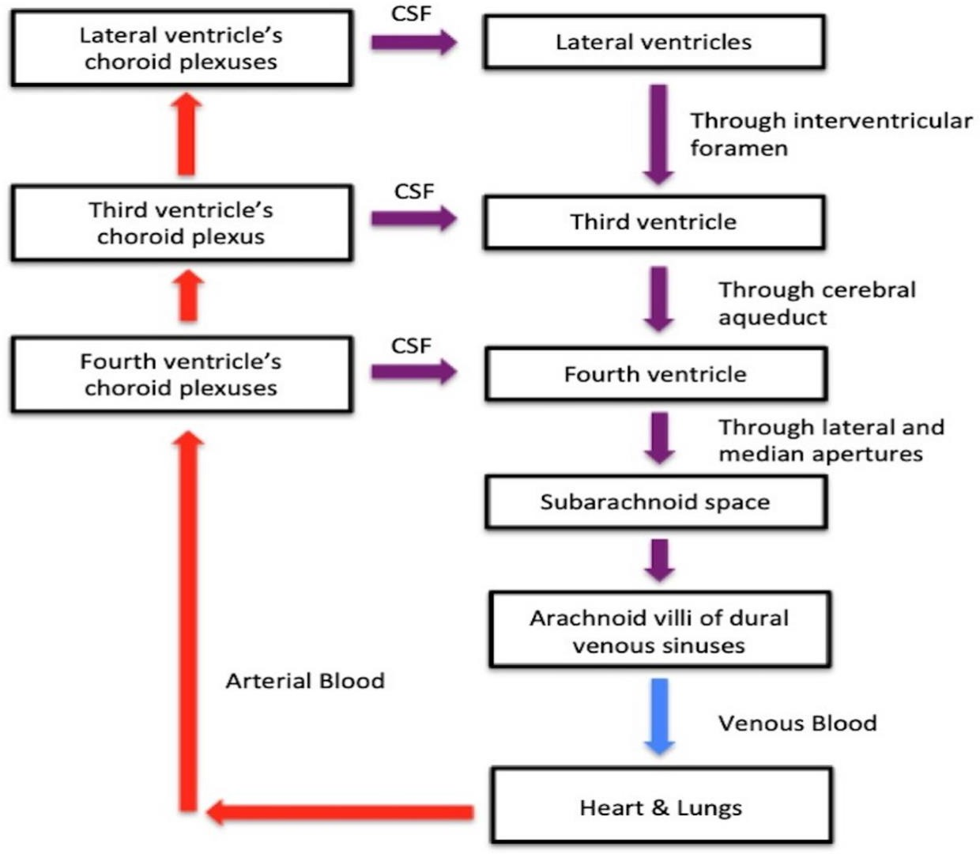

**Physical Characteristics of CSF Appearance:** Clear, Colorless, Odorless **pH:** Nearly equivalent to plasma

**Coagulation:** Normally CSF does not coagulate.

**CSF pressure:** 70-180 mmHg

## Site for CSF Collection

Needle is inserted in the Intervertebral space between L3 and L4 Vertebrae & CSF is collected from subarachnoid space of Spinal Cord. Fluid is collected in 3 different tubes.

* + For biochemical Tests - In fluoride (gray cap) & plain (red cap) vacuette .
  + For bacterial culture - In plain sterile vacutte (green cap)
  + For cell count-use EDTA vacuette (lavender Cap)

## CSF Functions:

1. Protective Function: Meninges and CSF protects the Brain by acting as a cushion and Shock Absorber
2. Nutritive Function & Excretory Function: It helps in Exchange of Substance between the Brain / Spinal Cord with the Main Blood Stream.

## Indications of CSF Analysis:

1. Infections: Meningitis and Encephalitis (Bacterial, Viral or Tubercular).
2. In trauma to diagnose Subarachnoid Hemorrhage.
3. Tumors of the Brain.
4. Degenerative Diseases of the Brain like Multiple Sclerosis.
5. In CVA (Cerebro-Vascular Accidents)

## Contraindications:

1. Raised intracranial tension
2. Local Skin Infections at the Site of Puncture

## Composition of CSF

* 1. Organic substances

Proteins, amino acid, glucose, cholesterol, urea, uric acid, creatinine, lactic acid.

* 1. Inorganic substance

Sodium, calcium, potassium, magnesium, chloride, phosphates, bicarbonate, sulfate.

**Comparison of CSF composition with Plasma**

|  |  |  |  |
| --- | --- | --- | --- |
| **Sr No** | **Component** | **CSF** | **Plasma** |
| 1 | Glucose | **50-75 mg/dl** | **100 mg/dl** |
| 2 | Protein | **15-45 mg/dl** | **6000-8000 mg/dl** |
| 3 | Chloride | **120-130 mEq/L** | **96-106 mEq/L** |
| 4 | Cholesterol | **0.2 mg/dl** | **175 mg/dl** |
| 5 | pH | 7.33 | 7.4 |
| 6 | Osmolality | 289 mOsmol/kg of water | 289 mOsmol/kg of water |

**CSF analysis**

|  |  |  |  |
| --- | --- | --- | --- |
| **Procedure** | **Principle** | **Observation** | **Inference** |
| **Tests for Protein** | | | |
| **Biuret Test**  2ml 5% NaOH + 2drops CuSo4.  Divide it into two parts. 1 part add Protein solution | CuSo4 + NaOH→ Cu (OH)2  Alkaline pH ↓  Cu produce coordinated complex with Peptide linkage | Pink or Violet color is produced.  Intensity of color depends on the number | Pink color indicates few peptide linkages and violet color indicates  many |

|  |  |  |  |
| --- | --- | --- | --- |
| and other part add  water as a control | * Insoluble proteins like keratin &  collagen do not give this test positive. | of peptide  bonds. | peptide  linkages. |
| **Sulphosalicylic Acid Test**  1 ml of CSF + 1 ml of 30%  Sulphosalicylic acid, mix. | Test is based on the precipitation of urine protein by a strong acid, sulfosalicylic acid. Precipitation of protein in the sample is seen as increasing turbidity. | White Turbidity indicates the presence of proteins. | Proteins present |
| **Pandy’s Test**  1 ml of CSF + 1 ml of pandy’s reagent | Carbolic acid present in reagent leads  to disorganization of peptide linkage of Globulin. | Turbidity or  Precipitations formed. | Globulin present |
| **Test for Reducing Sugar** | | | |
| **Benedict’s Test** 5ml of Benedict’s reagent + 8 drops/0.5 ml of sample mix. Boil for 2-3 minutes and allow precipitation to settle down. | Glucose (R-CHO) + 2Cu2+ + 2H2O  Gluconic acid + Cu2O + 4H+ When reducing sugars are heated in the presence of an alkali (pH 10.6), they get converted to powerful reducing compounds known as  enediols. Enediols reduce the cupric ions (Cu)2+ present in the Benedict's reagent to cuprous ions (Cu)+ which get precipitated as insoluble red copper(I) oxide. The color of the obtained precipitate gives an idea about the quantity of sugar present in the solution; hence the test is semi-  quantitative. | Blue to green to yellow to orange color precipitation is seen | Reducing sugar present |
| **Test for Chloride** | | | |
| **Silver Nitrate Test**  1 ml of CSF + 1 ml of Silver Nitrate,  mix. | Silver reacts with chloride present in the CSF to produce Silver Chloride | White precipitation of Silver Chloride is seen | Chloride is present. |

**Chemical Composition of CSF in Health & Diseases**

|  |  |  |  |  |  |  |
| --- | --- | --- | --- | --- | --- | --- |
|  | **Parameter** | **Normal** | **Bacterial Meningitis** | **Tubercular Meningitis** | **Viral Meningitis** | **Trauma** |
| **1** | Cell count | 0-4×106/l | **↑**  Polymorphs | **↑**  Lymphocytes, | ↑  Lymphocytes | RBC & WBC |

|  |  |  |  |  |  |  |
| --- | --- | --- | --- | --- | --- | --- |
|  |  |  |  | Mononuclear  cells |  |  |
| **2** | Color | Colorless | Turbid Due to Markedly Increased  Polymorphs | May be Opalescent | Clear | Reddish |
| **3** | Clotting | Not seen | Clots on standing | COBWEB  type coagulation | No Clot | No Clot |
| **4** | Protein | 15-45  mg/dl | ↑↑ | ↑ | Normal /↑ | ↑ |
| **5** | Sugar | 50-70  mg/dl | ↓↓ | ↓ | Normal | Normal |
| **6** | Chloride | 110-130 | ↓ | ↓↓ | Normal | Normal |

**QUESTIONS**

1. Explain the CSF picture in viral meningitis and bacterial meningitis
2. What is xanthochromia?
3. Name the conditions in which CSF coagulates.
4. Why does glucose level in CSF decrease in Pyogenic Meningitis?
5. Why does CSF have chloride concentration higher than that in Plasma?
6. What is the clinical significance of protein level in CSF?
7. What is CSF? What is the significance of CSF analysis?
8. How is CSF collected? What is its normal composition?
9. What is the difference between CSF and plasma as regards protein composition?
10. What are the normal levels of proteins, glucose and chlorides in CSF?
11. In which conditions are protein levels in CSF elevated?
12. How are CSF globulins measured?

# PRINCIPLES OF COLORIMETRY AND SPECTROPHOTOMETRY

**(BI 11.6, BI 11.18, BI 11.9)**

## Introduction

* + Colorimetry means measurement of color.
  + Technique used to measure Concentration of substances that are colored or that can be converted to colored compounds by reaction.

## Principle of Colorimetry

* + When a Monochromatic light (Light of a specific wavelength) falls on a colored solution, a proportion of incident light is absorbed by the colored solution and remaining light is transmitted. The amount of transmitted light depends upon concentration of color in solution, which depends upon concentration of colored producing substances.

## Factors affecting Transmittance of Light

* + The nature and concentration of substance in the colored solution
  + Wavelength of Incident light
  + Path length of the solution through which the light is passed

## Transmittance (T)

* + Photometric instruments measure the light emerging from solution as Transmittance (T).

*◻* = *◻◻*

*◻◻*

* + Where Ie is intensity of emergent light) and Io is intensity of incident light

*% ◻* = *◻◻*

*◻◻*

× *100*

* + The %T is inversely related to absorption i.e. if more light is absorbed, % T is less and vice versa.
  + Zero % Transmittance indicates that all the light is absorbed by Black cuvette and no light is transmitted.
  + If all the other factors are kept constant, (path length and light wavelength) and the concentration of substance is increased gradually then T will become less and less.

## Absorbance (A)

* + Absorbance is defined which gives a direct relationship with concentration of the substance in solution at a constant path length.

A = – log (% T)

A = log 100 – log T = 2 - log T

* + Absorbance has No Units. Absorbance is also called Optical Density (OD).

## Beer’s Law

* + When a beam of monochromatic light is passed through a solution, the absorbance (A) of the solution is directly proportional to the concentration (C) of the substance in solution.
  + The log of the ratio of intensities of incident light (Io) and emergent light (Ie) is directly proportional to the concentration of the chromogen (C) in the solution provided the length of the light path is constant.

## Lambert’s Law

*◻◻◻ ◻◻*

*◻◻*

∝ *◻* **Or** *◻* ∝ *◻*

* + According to this law, the absorbance (A) is directly proportional to path length of light (L) which is the width of solution.
  + States that the log of the ratio of intensities of incident light (Io) and emergent light (Ie) is directly proportional to the length of the light path (L) provided that the concentration of the chromogen is constant.

## Beer – Lambert’s Law

*◻◻◻ ◻◻* ∝ *◻*

*◻◻*

*◻* ∝ *◻◻*

or

*◻* = *◻◻◻*

* + Where k is extinction coefficient or absorption coefficient and is fixed for a given substance at specific concentration and wavelength. Routinely the concentration of the unknown is calculated by comparing the absorbance of solution of unknown substance with that of the solution of known concentration (Standard).

Where

*◻◻*

*◻◻* =

*◻*

*◻*

× *◻◻*

**Ct -** Concentration of Test Sample

**At –** Absorbance of Test Sample

**As –** Absorbance of Standard Sample

**Cs –** Concentration of Standard Sample

Following graph describes the relationship between T% and A.

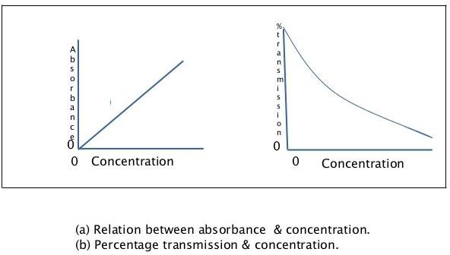

## Instrument:

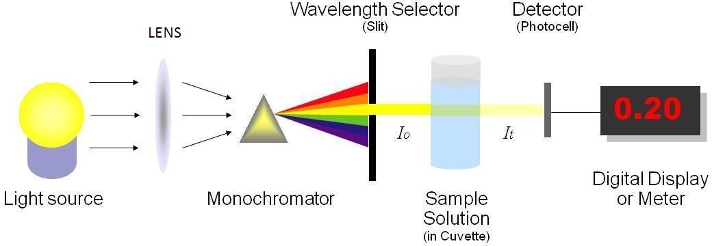

**Components of colorimeter:**

1. **Light Source:** A lamp provides light in a visible region of the spectrum. Usually, the Tungsten Lamp is the source of light.
2. **Adjustable Slit:** The light emerging from the tungsten lamp is allowed to pass through a narrow adjustable slit.
3. **Condensing Lens:** It provides a parallel beam of Light.
4. **Filters:** Colored Glass Filters or Dyed Gelatin. They absorb most of the light and permit light of the corresponding color only with sufficient narrow wavelength. It provides the desired monochromatic light (of single wavelength) by filtering other wavelengths. The color of the filter is complementary to the color of the solution. This allows only the appropriate wavelength of light to pass through the colored solution.

|  |  |  |  |
| --- | --- | --- | --- |
| **Filter (nm)** | **Filter color** | **Absorbed color** | **Color of solution to be analyzed** |
| 340 | UV (colorless) | UV (colorless) | Nucleic acid, Reducing Equivalent |
| 405 | Violet | Violet | Yellow green |
| 450 | Blue | Blue | Yellow |
| 505 | Bluish green | Blue green | Red |
| 546 | Green | Green | Red violet |
| 578 | Yellow | Yellow | Violet |
| 630 | Orange | Orange | Greenish blue |
| 670 | Red | Red | Blue green |

## Cuvette:

* + Cuvette can be square, rectangular or circular with a flat surface. Usually, it is 1 cm in Diameter & should be uniform in Thickness as absorbance is measured.
  + Cuvette must be Optically Transparent, Thoroughly Clean, Scratch less and free from Contamination. Volume of colored solution taken in the cuvette should not be less than 1 ml / 3 ml. It is the Minimum Volume specified for that particular cuvette.
  + Glass cuvette is used in Visible Range Colorimetric, whereas Quartz or Fused Silica Cuvette is used in UV Range.

## Photosensitive Detector

* + Photocell or phototube is used to convert transmitted light into electrical energy.
  + Photocell – A metal plate is coated with a thin layer of photosensitive elements such as Selenium. This in turn is coated with a thin transparent layer of a metal such as Gold or Copper.
  + Photosensitive Element is activated when light falls on it. It emits electrons Proportional to the amount of light falling on it. It converts light energy into electrical energy.

## Measuring Devices

* + The photodetector response can be measured by any of the following readout devices. Galvanometers or recorder
  + Digital readout: The Signal may be transmitted to a computer or print out device.

## Solution Preparation for Investigation

* + In Colorimetric Estimation, it is necessary to prepare three solutions viz. Blank (B)

Standard (S) Test (T)

## Blank

* + Blank solution is prepared to delete the color due to reagents. Since some reagents are colored, they add on to the color produced by the substance, which is to be estimated. This increase in the intensity of color in turn gives high concentration of the substance to be estimated.
  + Alternatively, the blank solution is used to set the meter of the instrument to 100% Transmittance (T) or zero absorbance
  + The value of blank is subtracted from tests and standard.
  + A blank is prepared by using all reagents except the biological material to be estimated.

## Type of Blank

* + Water Blank: It is used to adjust the OD to zero and T to 100%
  + Reagent Blank: It is prepared by adding all reagents except the substance to be estimated.

## Standard

* + It is a solution of known concentration of the substance in pure form, which is to be estimated. As both concentration and OD of the standard solution are known, the concentration of unknown can be calculated by using formula.

## Test

* + Test solution is prepared by treating specific volume of the test sample with the reagents as specified in the procedure.

## Calculations

**Percent Concentration of Analyte in Test sample =**

O.D. of Test- O.D. of Blank X Concentration of Standard

O.D. of Std. – O.D. of Blank

## Application of Colorimeter

* + Colorimetric procedure is widely used in laboratories for the estimation of various Biochemical Compounds in various biological samples like Blood, Plasma, Serum, CSF, Urine and other body fluids.
  + By using colorimeter principle routinely estimated Biochemical Parameters (with equipment like Colorimeter, Spectrophotometer, Semi automated biochemistry analyzer and fully automated biochemistry analyzer) are Glucose, Urea, Creatinine, Uric Acid, Bilirubin, Lipids, Total Protein and Enzymes like AST, ALT, ALP, Minerals like Calcium, Phosphorus etc.

1. **Advantage: -** It is very easy to operate.

## Disadvantages: -

* + Less sensitive.
  + Limited range of filters are available.
  + If the light source is not stable, there is a possibility of errors due to a change from the initial light intensity during a measurement.
  + The manual operation is limited.

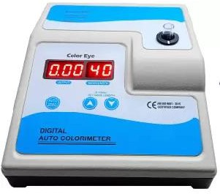

1. **Colorimeter**

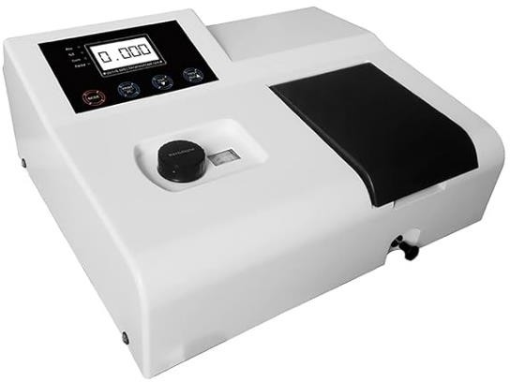

1. **Spectrophotometer**

**Difference between Colorimeter & Spectrophotometer**

|  |  |
| --- | --- |
| **Colorimeter** | **Spectrophotometer** |
| Limited for the visible portion of spectrum (visible light) | Ultraviolet & infrared region also visible e.g.340 nm |
| Cheap | Costly |
| Two digits reading after decimal point. | Four digits reading after decimal point. |
| Less sensitive | More sensitive |
| Colored Glass is used as a filter. | Prism is used as a filter. |
| Can't do the kinetic method. | Can do kinetic methods. |
| Can't use specific filter | Can use a specific filter. |
| Tungsten lamps are used. | Halogen lamps are used. |

**Questions:**

1. Write the Principle of Colorimetry.
2. Mention the relationship between Absorbance and Transmittance giving emphasis on Beer's Law and Lambert's Law.
3. Mention factors affecting Transmittance of Light during Colorimetry Practical.
4. Mention the wavelengths of Visible, Infrared and U.V rays in Light spectrum. What is the range of wavelengths in which a Photo Colorimeter works?
5. What is Complimentary Color?
6. Write down the difference between Colorimeter and Spectrophotometer.
7. Write down the difference between Semi auto and fully auto analyzer.
8. What do you mean by blank, standard and test?
9. Which type of cuvette bottom (flat or round type) is required?

## Exercise:1

* + You will be given a concentrated colored solution.
  + Dilute it in a series of test tubes as follows. Measure absorbance.

|  |  |  |  |  |
| --- | --- | --- | --- | --- |
| Test  tube | Diluted Red Dye  (microliter) | Buffer or DI Water  (microliter) | Dilution Ratio  (X- Axis) | Absorbance (A) on 505  nm Filter(Y-Axis) |
| 0 | 0 | 1000 | 0 % |  |
| 1 | 200 | 800 | 20 % |  |
| 2 | 400 | 600 | 40 % |  |
| 3 | 600 | 400 | 60 % |  |
| 4 | 800 | 200 | 80 % |  |
| 5 | 1000 | 0 | 100 % |  |

* + Draw Graph of various Dilution of dye versus its absorbance

## Result & Conclusion:

**Exercise-2**

* + You will be given two different colored dye. Measure Absorbance of given colored solutions on different filters.

|  |  |  |
| --- | --- | --- |
| Filters(nm) (X-Axis) | Absorbance (Y-Axis) | |
| Red colored solution | Blue colored solution |
| 340 |  |  |
| 405 |  |  |
| 505 |  |  |

|  |  |  |
| --- | --- | --- |
| 546 |  |  |
| 630 |  |  |

* + Note: Different colored solutions absorb light at different wavelengths in different proportions.
  + Draw Graph of various filters versus absorption on that filter for red colored solution & Blue colored solution.

**Result & Conclusion:**

1. **ESTIMATION OF PLASMA GLUCOSE (BI11.21)**

**Importance**

* + Although ‘Blood Sugar’ includes all different types of hexoses, the main hexose sugar present in blood is glucose. Hence, effectively blood sugar means glucose.
  + Blood Glucose level is an important indicator of body functions, and its level has to be actively maintained within specific biological reference range.
  + It is an essential nutrient for the brain and RBCs. Abnormalities in blood glucose level usually indicate disturbances in carbohydrate metabolism.
  + Routine plasma glucose is estimated for diagnosis and follow up for patients suffering from diabetes mellitus in hypoglycemic conditions.

## Patient’s Preparation

* + Patients must be overnight fast (8-10 hours) for Fasting Plasma Glucose estimation.
  + Blood is collected 2 hours after lunch for Postprandial Plasma Glucose estimation.

**Patients Sample:** Blood Sample is collected in Fluoride Vaccute/ vial & Plasma is separated for glucose estimation.

**Method:** Glucose Oxidase-Peroxidase Method

**Principle**: Glucose oxidase converts glucose to gluconolactone which spontaneously converts to gluconate. The hydrogen peroxide produced is then broken down to oxygen and water by a peroxidase enzyme. Oxygen then reacts with an oxygen acceptor such as phenolic 4- aminophenazone to produce Quinonimine- red color.

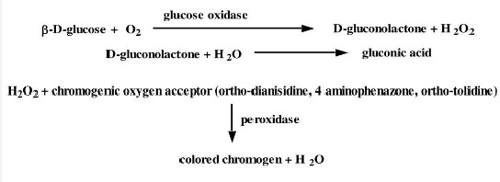Absorbance is taken at 505 nm.

## Procedure:

|  |  |  |  |
| --- | --- | --- | --- |
| **Reagents** | **Blank** | **Standard** | **Test** |
| Glucose Oxidase-Peroxidase Reagent |  |  |  |
| Distilled water |  |  |  |
| Standard |  |  |  |
| Sample |  |  |  |
| Mix & Incubate At room temperature for 15 min. Then take absorbance at 505 nm. | | | |

**Measurement of OD:**

O.D. of Blank =

O.D. of Standard =

O.D. of Test = Glucose Standard Concentration =

## Calculation:

Concentration of glucose (mg/dl )=

O.D. of Test- O.D. of Blank X Concentration of Standard

O.D. of Std. – O.D. of Blank

**Your result =**

**Comment on your result:**

**Criteria for the diagnosis of Prediabetes & Diabetes:**

|  |  |  |  |
| --- | --- | --- | --- |
| Parameter | Biological Reference Interval | Prediabetes | Diabetes |
| HbA1c | < 5.7 | 5.7-6.4 | >/= 6.5 |
| Fasting plasma glucose | 70-100 mg/dL | 100-125 mg/dL | >/= 126 mg/dL |
| 2 hour postprandial Blood Glucose | Below 140 mg/dL | 140-199 mg/dL | >/= 200 mg/dL |
| Random Blood Glucose | - | - | >/= 200 mg/dL |

**Criteria for the diagnosis of diabetes:**

1. **HbA1c >/= 6.5 \***

Or

1. **Fasting plasma glucose >126 mg/dL**. Fasting is defined as no caloric intake at least for 8 hrs.

Or

1. **Two-hour plasma glucose >/= 200 mg/dL** during an oral glucose tolerance test by using a glucose load containing equivalent of 75 gm anhydrous glucose dissolved in water.

Or

1. In a patient with **classic symptoms** of hyperglycemia or hyperglycemic crisis, a r**andom plasma glucose >/= 200 mg/dL.** *In the absence of unequivocal hyperglycemia.

## Different methods of Glucose Estimation:

**Hexokinase Method:**

Principle: Hexokinase act on Glucose to form Glucose 6 Phosphate. It is the oxidized by glucose 6 Phosphate Dehydrogenase to release NADH, which is measured 340 nm (UV Range) by Spectrophotometer.

## Historic Methods:

Based on reducing properties of Glucose:

* 1. Folin Wu Method
  2. Nelson Somogyi Method
  3. Orthotoluidine Method King
  4. Asatoor Method

**Point of Care Testing (POCT) - Blood Glucose Estimation with Glucometer:** Through glucometer, management of diabetes will improve as patients, them self can perform testing and doctor also can perform on the site.

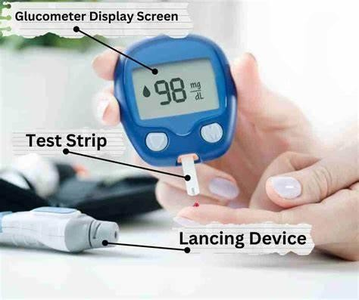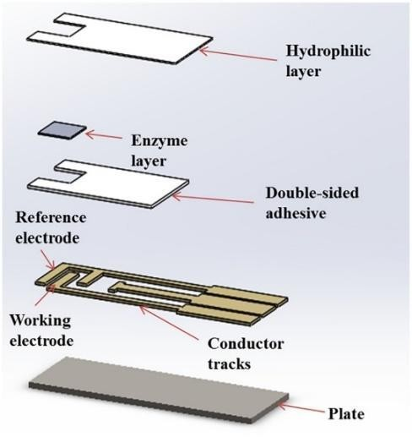

Indication:

* + - Type 1 DM, Uncontrolled and Insulin Dependent Type 2 DM, GDM
    - A glucose meter or glucometer, is a medical device used for measuring the approximate level of glucose in the blood by people as self-monitoring of blood glucose
    - To do glucose testing, a diabetic uses a glucose testing meter, which uses a glucose testing strip.
    - Most glucose meters are based on electrochemical technology, they use electrochemical test strips to perform the measurement.
    - A small drop of the blood by fingerpick with lancing devices, is placed on a disposable test strip, that the glucose meter uses for the glucose measurement.

Working Principle of Glucose Meter:

Amperometric Method:

* + - In this method, the electrochemical test strip contains a capillary that is used to draw in the solution placed at one end of the test strip. The test strip also contains an enzyme electrode containing a reagent such as Glucose Oxidase.
    - Glucose undergoes a chemical reaction in the presence of enzymes and electrons are produced during the chemical reaction. These electrons (i.e, the charge passing

through electrode) are measured and this is proportional to the concentration of glucose in the solution.

* + - An ambient temperature measurement is also made in order to compensate for the effect of temperature on the rate of reaction.
    - The solution sample (Blood) is placed on the test strip and the reaction of the glucose with the enzyme takes place. The flow of electrons will correspond to the flow of current through the working and the reference electrodes. This current will change according to the glucose concentration.
    - The current is measured using a trans-impedance amplifier (current-to-voltage converter) and an analogue-to-digital converter (ADC). The output of the trans- impedance amplifier will be seen as a variation in the voltage with varying glucose concentrations in the solution.

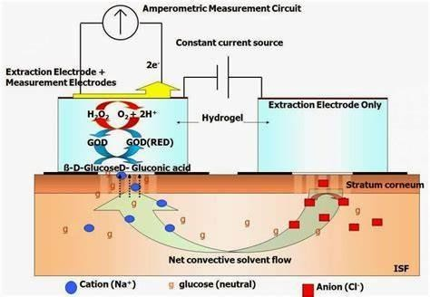

Factors affecting Glucose measurement:

* + - Temperature
    - Humidity
    - Altitude, etc.

This is because the rate of the enzyme reaction depends on these and the other factors.

## CONTINUOUS GLUCOSE MONITORING:

Continuous glucose monitoring means using a device to automatically estimate your blood glucose level continuously and reading stored in devices at every 15 minutes, throughout the day and night. Consisting of a handheld reader, and a disposable sensor worn on arm.

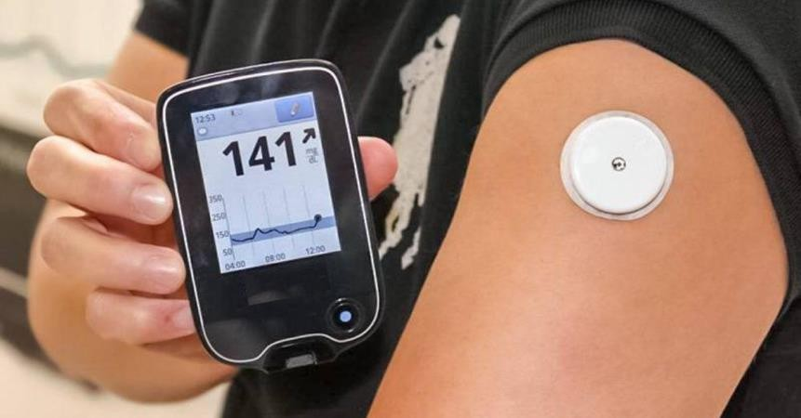

## Questions:

1. Write reference range in various conditions in mmol/L. (Glucose MW=180 gm)
2. Write clinical conditions for increasing and decreasing glucose level in plasma.
3. Write advice to be given to a person for fasting blood sugar (FBS) and postprandial blood sugar (PP2BS) estimation.
4. Why is Fluoride Vaccute used for plasma glucose collection?
5. What are the advantages of the Enzymatic method of Plasma glucose estimation?
6. What are fasting, postprandial and random blood sugar (FBS, PPBS and RBS) samples?
7. Why is plasma glucose concentration more than that of whole blood?
8. How much glucose is present in 1 pint of 5% dextrose saline that is used as IV Infusion in patients?
9. How is the blood glucose level regulated?
10. What are the ADA criteria for diagnosing diabetes mellitus?

## ORAL GLUCOSE TOLERANCE TEST (O.G.T.T)

**Definition:**

Ability of a person to metabolize a given load of glucose is referred to as glucose tolerance. To assess the status of carbohydrate metabolism a known quantity of glucose is administered, and the level of glucose is assessed. It is a well standardized test.

## There are two types of O.G.T.T. Standard and Mini GTT

**Standard O.G.T.T:** Fasting blood sample & urine samples are collected. The patient is given 75 gm glucose dissolved in 250-300 ml water. Blood & Urine samples are collected every 30 minutes for 2 hours.

Estimation of blood sugar by GOD-POD/Hexokinase method. Urine is qualitatively analyzed by Benedict’s method. (Fasting to 2 hours, total 5 samples)

## Mini GTT:

The present WHO recommendation is to collect only the fasting and PG2BS sample of blood. This is sometimes called mini-GTT. This is sufficient to get a correct assessment of the patient.

## Indications:

* Patient has symptoms suggestive of diabetes mellitus with IFG or IGT
* Diagnosis of Gestational Diabetes Mellitus (GDM)
* Patient with diabetes complications-Retinopathy, Nephropathy and RBS <140 mg%
* Population Studies (Screening) for epidemiological data

## Contra-indications:

* There is no need to do OGTT on a confirmed diabetic patient, follow up case of DM.
* The test should not be done on an acutely ill person.

## Preparation of the patient:

* Non-pregnant person (18 Years)
* The patient was instructed to have a carbohydrate rich diet (>150 gm carbohydrate) for three days prior to the test. Further diet containing about 30 to

50 gm of carbohydrate should be taken in the evening prior to the test. This is important. Otherwise, carbohydrates may not be tolerated even in the normal person.

* Patient should avoid drugs likely to influence blood glucose level (oral hypoglycemic drugs, Insulin etc.) For at least two days prior to the test.
* Vigorous exercise on the previous day is to be avoided.
* Patient neither should take food after 8 PM the previous night nor should take breakfast to ensure twelve hours fasting.
* Patient should abstain from smoking and drinking during the test.
* Sample of blood collected in the fasting stage by venipuncture.

## Glucose Load:

* Patient is given 75 gm of glucose dissolved in 250 to 300 ml of water. Patient is advised to drink it slowly in order to avoid vomiting. In case of children the glucose is adjusted as 1.75 gm/kg body weight.
* Blood sample is collected by venipuncture as described above exactly 2 hours Glucose load.

## During Pregnancy:

* + Gestational Diabetes Mellitus (GDM) is defined as Impaired Glucose Tolerance (IGT) with onset or first recognition during pregnancy. Testing for GDM is recommended twice during ANC. The first testing should be done during first antenatal contact as early as possible in pregnancy. The second testing should be done during 24-28 weeks of pregnancy if the first test is negative. It is important to ensure a second test as many pregnant women develop blood sugar intolerance during this period (24-28 weeks). There should be at least a 4-week gap between the two tests. The test is to be conducted for all pregnant women even if she comes late in pregnancy for ANC at the time of first contact.
  + Single step test recommended by WHO for diagnosis of GDM using a 75-gm glucose, through Oral Glucose Tolerance Test (OGTT) irrespective of the last meal with a threshold value of 2-hour BS>140 mg/dL.

## Interpretation:

1. **Alimentary glycosuria**

Here the fasting and PG, BG are within normal limits but an exaggerated rise in blood glucose following ingestion of glucose is observed. This is due to an increased rate of

absorption of glucose from the intestine. This may occur in patient after gastrectomy or in hyperthyroidism.

## Renal Glycosuria

Here the glucose is excreted in urine while the sugar levels are within normal limits. This is due to lowering renal threshold value (180 mg/dl)

## Flat GTT

A flat GTT curve is observed to be much lower than normal people. This is found in Malabsorption, Hypopituitarism and Addison's disease.

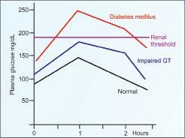

**Questions:**

1. Why 3 days of unrestricted diet (> 150 gram High carbohydrate/day) is advised prior to day of OGTT?
2. Mention the indications of OGTT.
3. Why is OGTT mandatory in all pregnant women?
4. What is the difference between PP₂BS and PG₂BS?
5. What is renal glycosuria?

# Estimation of serum creatinine and creatinine clearance (BI 11.7 & BI 11.22)

Creatinine is produced from creatine present mainly in muscles. It is filtered by glomerulus of the kidney.

## Importance:

1. Creatine is synthesized in the liver & kidney, it passes in to circulation & is taken up almost entirely by skeletal muscles for conversion to creatine phosphate which serves as a storage form of energy in skeletal muscles.
2. Creatinine is produced in muscles from high energy compound Cr~P.
3. The amount of creatinine produced is related to the total muscle mass & remains almost the same in the plasma & urine on a day-to-day basis unless muscle mass changes.
4. So serum creatinine is a sensitive index of renal function because it is dependent on the muscle mass & renal excretion & dietary Intake of proteins does not change serum creatinine concentration
5. Creatinine clearance is a good measure of GFR.

## Principle (Alkaline Picrate Method / Jaffe’s method):

Picrate + OH- → activated [Picrate-OH-] complex

[Picrate-OH-]* + creatinine → Creatinine-Picrate complex + OH-

Red colored Creatinine-Picrate complex, also called Janovaski complex, is measured at 505 nm.

The rate of reaction is proportional to concentration of creatinine.

The rate of reaction is also indicated by rate of rise in Absorbance (ΔA)

Thus, [creatinine] ∞ ΔA ΔA for standard is ΔA standard and ΔA for sample is ΔAsample **Creatinine Standard:** (2 mg/dl Creatinine)

## Creatinine Reagents:

* **Creatinine R 1:** NaOH
* **Creatinine R 2:** Picric acid

## Procedure:

* 1. Take 500 µl R1 & 500 µl R2 add 50 µl of sample / standard.
  2. Mix it and analyze it immediately at 505 nm wavelength.
  3. Note the absorption (Optical Density=O.D.) at the end of Delay time & Read time.
  4. Calculate change in O.D. ΔA = A read time- A delay time

## Calculation and Result:

|  |  |  |  |  |  |
| --- | --- | --- | --- | --- | --- |
| ΔA of Standard | = ( | )Aread time | - ( | ) Adelay time | = |
| ΔA of Sample | = ( | )Aread time | - ( | ) Adelay time | = |

*◻◻◻◻◻◻◻◻◻◻◻◻◻ ◻◻ ◻◻◻◻◻◻◻◻◻◻* = ∆*◻◻◻◻◻◻◻* ×

∆*◻◻◻◻◻◻◻◻◻*

*◻◻◻◻◻◻◻◻◻◻◻◻◻ ◻◻ ◻◻◻◻◻◻◻◻* (1)

Your result

**Comment on your result :**

**Reference Range**:

|  |  |  |
| --- | --- | --- |
| **Age** | **S. Creatinine mg %** | **Creatinine Clearance**  **ml/min** |
| < 12 yrs | 0.5 - 0.85 mg% | 50-90 |
| Adult Male | 0.7 – 1.4 mg% | 97-137 |
| Adult Female | 0.4 - 1.2 mg% | 88-128 |

**Interpretation:**

**Causes of increased level of S. Creatinine**

* Urinary tract obstruction
* Prostatic hypertrophy
* Calculus obstructing the ureter
* Neoplasm compressing ureter
* Diabetic nephropathy
* Exposure to nephrotoxic drugs: NSAID, Aminoglycosides
* Chronic nephritis
* Renal Failure

## Causes of decreased level of S. Creatinine

* It is associated with Muscle wasting disease

**Creatinine Clearance.** - It is defined as the volume of plasma cleared off creatinine by both the kidneys in one minute. It is expressed as ml of plasma per minute. As after filtration, there is no reabsorption & little secretion of creatinine by renal tubules. It is useful for long term monitoring of patients of renal insufficiency.

## Estimation of Creatinine Clearance.

Where

*◻◻◻◻◻◻◻◻◻◻ ◻◻◻◻◻◻◻◻◻* =

*◻* × *◻*

*◻*

U =urinary Creatinine

V = 24-hour Urine Output

P = Plasma/Serum Creatinine

**Reference range**

**Healthy women = 88-128 mL/min.**

**Healthy male = 97 to 137 mL/min.**

**B .eGFR (estimated creatinine clearance)**

eGFR is estimated GFR calculated by the abbreviated MDRD equation:

186 x (Serum creatinine/88.4)-1.154 x (Age)-0.203 x (0.742 if female) x (1.210 if negro).

|  |  |
| --- | --- |
| **Stages of renal failure** | **eGFR mL/min/1.73 m2** |
| **I** | **≥ 90** |
| **II** | **60-89** |
| **IIIa** | **45-59** |
| **IIIb** | **30-44** |
| **IV** | **15-29** |
| **V** | **< 15** |

## Questions:

1. Express adult plasma creatinine reference range.
2. Write clinical conditions in which serum creatinine increases.
3. What is creatinine & what is the importance of estimating serum creatinine level?
4. What is the difference between creatine and creatinine?
5. What is the method used to estimate serum and urinary creatinine?
6. Name the conditions with increased urinary creatinine levels.
7. What is creatinine clearance?
8. What is the creatinine coefficient?
9. What is an ideal substance that can be used to determine GFR? Why?
10. Which is a better indicator of renal function: blood urea or creatinine? Why?

# Estimation of Serum Urea (BI11.21)

## Importance

Blood Urea level is the most estimated parameter to assess renal functions. Urea is the major metabolic waste product of both exogenous & endogenous proteins.

It constitutes more than 75% of total Non-Protein Nitrogen (NPN) excreted by Kidney. It is freely filtered by Glomeruli but not actively reabsorbed or secreted.

## Principle (Urease Method)

Urea in the sample is hydrolyzed enzymatically into ammonia and CO2.Ammonia ions react with alpha-ketoglutarate in a reaction catalyzed by Glutamate dehydrogenase (GLDH) with simultaneous oxidation of NADH to NAD+. The decrease in concentration of NADH is proportional to urea concentration in the sample.

Urea + H2O + 2H+  Urease 2 NH3 + CO2

2 NH3 + ketoglutarate + NADH  GLDH H2O + NAD+ +L-Glutamate.

The rate of absorbance change at 340 nm is directly proportional to Urea activity in the sample. Δ OD = Δ (Read time) - Δ (delay time)

## Urea Standard:

**Urea Reagents:**

* **Urea R 1:** Urease, Glutamate dehydrogenase, ketoglutarate
* **Urea R 2:** NADH

## Procedure:

1. Take 800 µl R1 & 200 µl R2 and add 10 µl of sample / standard.
2. Mix it and analyze it immediately at 340 nm wavelength.
3. Note the absorption (Optical Density=O.D.) at the end of Delay time & Read time.
4. Calculate change in O.D. ΔA = A read time- A delay time

## Calculation and Result:

|  |  |  |  |  |  |
| --- | --- | --- | --- | --- | --- |
| ΔA of Standard | = ( | )Aread time | - ( | ) Adelay time | = |
| ΔA of Sample | = ( | )Aread time | - ( | ) Adelay time | = |

*◻◻◻◻◻◻◻◻◻◻◻◻◻ ◻◻ ◻◻◻◻* = ∆*◻◻◻◻◻* ×

∆*◻◻◻◻◻◻◻◻◻*

*◻◻◻◻◻◻◻◻◻◻◻◻◻ ◻◻ ◻◻◻◻◻◻◻◻*

Your result

## Comment on your result :

**Reference range**:

Serum: 15-45 mg/dl

Urine 12-20 gm/day

## Causes of Increased urea level in blood

* **Prerenal**
  + Severe diarrhea & vomiting
  + Burns & shock
  + Massive hemorrhage
  + Fluid depletion as in diabetic ketoacidosis
  + Increased protein catabolism as in high fever & Thyrotoxicosis

## Renal

* + Acute glomerulonephritis
  + Acute & chronic renal failure

## Post Renal

* + Prostate enlargement
  + Urinary tract stones
  + Urethral stricture
  + Cancer of urinary Bladder

## QUESTIONS

1. What is the Normal Value of Urea in Blood?
2. Where is Urea formed in our body?
3. Define BUN. Write the difference between Urea & BUN.
4. What is Azotemia & Uremia?
5. What are the methods by which urea can be estimated in blood?
6. What is the commonest indication to assess blood urea levels?
7. What are the conditions in which blood urea levels are increased?
8. Name conditions where the urea level in blood is decreased.

# Estimation of serum Total Proteins (BI 11.21)

## Introduction:

Proteins present in Serum include Albumin, Globulin and Fibrinogen. Fibrinogen is used in clotting, hence not present in Serum. Hence Serum proteins are Albumin & Globulin. Except immunoglobulins, majorities of plasma proteins are synthesized by the liver.

Various tissues catabolize plasma proteins. Plasma protein concentration reflects balance between their synthesis and catabolism. Under certain conditions intact proteins from plasma are also lost through GIT, urine and skin. Proteins from the intravascular compartment may reach other body compartments. Protein concentration may also be affected by change in plasma water.

## Principle (Biuret Method) :

Two or more peptide bonds of proteins form coordination complexes with one cu2+ in alkaline solutions to form a colored product. The absorbance of the product is determined spectrophotometrically at 540 nm.

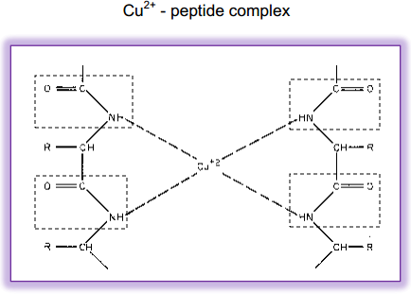

**Reagents**: Biuret solution that contains Copper Sulphate, Sodium Potassium Tartrate, NaOH, Potassium Iodide.

## Total Protein Standard: Procedure:

|  |  |  |  |
| --- | --- | --- | --- |
| **Reagents** | **Blank** | **Standard** | **Test** |
| H2O |  |  |  |
| Protein standard |  |  |  |
| Sample |  |  |  |
| Biuret reagent |  |  |  |
| Mix and incubate at 370 C temperature for 10 min. Read Absorbance at 540 nm | | | |

**Calculation and result:**

O.D. of Blank =

O.D. of Standard =

O.D. of Test =

Total Protein Standard Concentration =

Total Protein (gm/dL ). = *◻*.*◻*. *◻◻ ◻◻◻◻*−*◻*.*◻*.*◻◻ ◻◻◻◻◻* ×

*◻*.*◻*.*◻◻ ◻◻◻◻◻◻◻◻*−*◻*.*◻*.*◻◻ ◻◻◻◻◻*

*◻◻◻◻◻◻◻◻◻◻◻◻◻ ◻◻ ◻◻◻◻◻◻◻◻*

**Your result:**

**Comment:**

**Reference ranges:**

* Total serum proteins: 6.0-8.0 g/dL
* Albumin: 3.5-5.5 g/dL
* Globulin: 2.0-3.6 g/dL
* Fibrinogen: 0.2-0.6 g/dL

## Causes of hypoproteinemia

1. Decreased protein intake: Kwashiorkor
2. Decreased protein absorption: Malabsorption syndrome
3. Decreased Protein Synthesis: Cirrhosis of Liver, Severe liver disease
4. Intestinal loss: Protein losing enteropathy
5. Loss from the skin: Burns
6. Increased Urinary loss: Nephrotic Syndrome and Glomerulonephritis
7. Hemodilution: Excessive iv fluids

## Causes of hyperproteinemia

1. Multiple Myeloma
2. Macroglobulinemia
3. Hemoconcentration due to dehydration
4. Chronic collagen disease.

## Questions

1. Enumerate conditions associated with hypoproteinemia & hyperproteinemia.
2. Why reference ranges for plasma proteins cannot be expressed in mmol?
3. Which plasma protein is synthesized extrahepatic ally?
4. Mention the site of synthesis of Albumin and Globulin.
5. Write the principle of the Biuret test.
6. Give the reason for hypoproteinemia in Nephrotic syndrome.
7. Give the reason for hypoproteinemia in Cirrhosis of liver
8. Give the reason for hyperproteinemia in Multiple Myeloma.

# Estimation of Serum Albumin and A:G ratio (BI 11.8 & BI11.22)

Different disorders affect different plasma proteins differently. Thus, it is useful to know albumin and globulin concentration in serum, in addition to total protein. Once total protein and albumin (as shown below) are estimated, serum globulin can be calculated.

## Principle (Bromocresol Green Method):

At pH below 4.7 yellow colored Bromocresol green is in undissociated form. At pH above 4.7 blue colored Bromocresol green is in dissociated form.

Albumin combines with the BCG in pH below 4.7 to form an albumin-BCG complex, which is yellowish green. The depth of yellowish green is proportional to the concentration of albumin. The serum albumin concentration can be calculated by measuring the OD value at 620 nm.

**Reagents:** BCG solution **Albumin standard: Procedure:**

|  |  |  |  |
| --- | --- | --- | --- |
| **Reagents** | **Blank** | **Standard** | **Sample** |
| H2O |  |  |  |
| Standard |  |  |  |
| Sample |  |  |  |
| BCG reagent |  |  |  |
| Mix, and take absorbance at 620 nm after 1 minute. | | | |

## Calculation and result:

|  |  |  |
| --- | --- | --- |
| O.D. of Blank | = |  |
| O.D. of Standard | = |  |
| O.D. of Test | = |  |

Albumin Standard Concentration =

[ O.D. of Test ] - [ O.D. of Blank ]

Albumin (gm/dL). = ----------------------------------------- X Std.Conc.

[O.D. of Std. ] - [ O.D. of Blank ]

Your result

## Comment on your result

**Causes of hypoalbuminemia**

* Decreased intake: Kwashiorkor
* Decreased synthesis: Cirrhosis of liver
* Increased urinary loss: Nephrotic syndrome, Glomerulonephritis
* Decreased intestinal absorption: Chronic diarrhea, Malabsorption
* Increased catabolism: high grade fever, Hyperthyroidism
* Increased loss of blood: Trauma
* Increased loss from Skin: Burns

## Reference ranges:

* Serum Total proteins 6.0-8.0 g/dL
* Serum Albumin 3.5-5.5 g/dL
* Serum Globulins 2.0-3.6 g/dL
* Plasma Fibrinogen 0.2-0.6 g/dL

**A:G ratio**

## Clinical Significance of A: G (Ratio)

A:G ratio is the ratio of serum albumin and serum globulin.

A: G Ratio is decreased and sometimes even reversed in cases of true reduction in albumin as seen in liver diseases such as cirrhosis, renal diseases leading to albuminuria etc. But in cases of false alterations of total protein levels, A:G ratio will remain the same (e.g. Hemoconcentration)

## Calculate A:G ratio.

Globulin concentration = Serum total protein concentration- Albumin concentration Total protein concentration = g/dl

Serum albumin conc. = g/dl Serum globulin conc. = g/dl A:G ratio =

## Questions

1. What is the normal conc. of Serum Albumin?
2. Hypoalbuminemia is associated with edema. Justify.
3. What is the Clinical Significance of Albumin to Globulin Ratio?
4. In Which Condition A: G ratio is inversed?
5. Causes of Hypoproteinemia.

# Estimation of serum Bilirubin (BI11.12)

## Introduction:

Bilirubin is the end product of Heme degradation. About 300 mg% produced per day**.** About 250 mg% derived due to turnover of hemoglobin released from erythrocytes, after completion of their life span of 120 days.

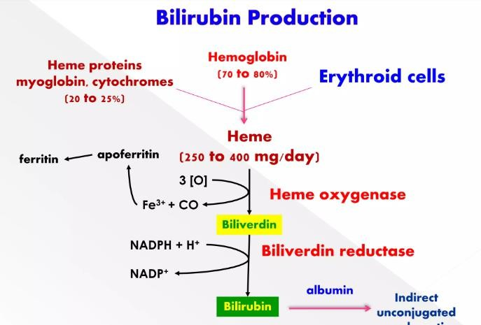

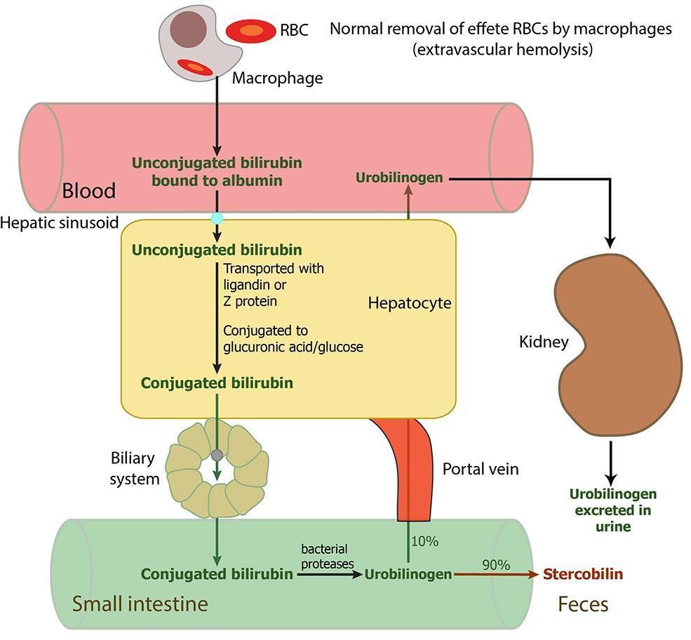

## Principle (Diazo Method):

One molecule of bilirubin reacts with two molecules of diazotized sulfanilic acid (diazo mix) in an acid solution to form two purple azobilirubin molecules (560 nm). Direct bilirubin reacts in water as well as with accelerator (e.g. caffeine, methanol) , while indirect bilirubin reacts only in presence of accelerator.

## Reagents:

R1: Caffeine Reagent R2 Diazo reagent

## Standard:

**Procedure**

|  |  |  |  |
| --- | --- | --- | --- |
| **Reagents** | **Test Blank** | **Standard** | **Test** |
| Blank |  |  |  |
| Standard |  |  |  |
| Sample |  |  |  |
| R1 (Caffeine Reagent) |  |  |  |
| Incubate for 10 minutes | | | |
| R2 (Diazo Mix) |  |  |  |
| Incubate for 10 minutes. Take absorbance at 560 nm | | | |

Blanks are taken to subtract absorbance caused by hemolysis (resulting in presence of red color of hemoglobin in serum). Diazo blank reagent does not have sodium nitrite, hence do not produce azobilirubin.

**Calculation:**

O.D. of Blank =

O.D. of Standard =

O.D. of Test =

Cholesterol Standard Concentration =

[ O.D. of Test ] - [ O.D. of test.Blank ]

Total Bilirubin (mg/dL). = ----------------------------------------- X Std.Conc

[O.D. of Std. ] - [ O.D. of std.Blank ]

**Result:**

Total Bilirubin (mg/dL) =

## Interpretation:

**Reference ranges: (For Adults)**

Total Bilirubin 0.2- 1.2 mg/dl

Direct Bilirubin < 0.2 mg/dl

Indirect Bilirubin < 1.3 mg/dl Bilirubin = MW 584.67 gm

1 mmol=1000 micromole

## Questions

1. Express Reference ranges in micromole/Liter.
2. Why should a sample for bilirubin not be exposed to light?
3. Explain how phototherapy is useful in treatment of neonatal jaundice.
4. What are the causes of Hemolytic Jaundice?
5. What is the Physiological Jaundice of Newborns? Write the causes.
6. Mention the cause of increase in Indirect Bilirubin Value in Hemolytic Jaundice.

# Estimation of Serum SGPT (BI 11.13)

## Introduction

Alanine Amino Transferase catalyzes the interconversion of amino acids and Keto Acids by transfer of amino groups. The enzyme ALT (Alanine Aminotransferase or Glutamate Pyruvate Transaminase) has been found to be in highest concentrations in the liver, with decreasing concentrations also found in Kidney, Heart, Skeletal Muscle, Pancreas, Spleen and Lung respectively. Elevated levels of ALT in serum are observed in Parenchymal Liver Diseases (eg. Viral Hepatitis and Cirrhosis), since ALT is a more liver specific enzyme.

## Principle(Enzymatic without PLP)

L-Alanine + 2-Oxoglutarate   SGPT Pyruvate + L-Glutamine

Pyruvate + NADH  LDH L-lactate + NAD+

The rate of absorbance change at 340 nm is directly proportional to ALT activity in the sample.

Δ OD = Δ (Read time) - Δ (delay time)

## ALT Standard:

**ALT Reagents:**

* **ALT R 1:** Alanine, Lactate dehydrogenase, ketoglutarate
* **ALT R 2:** NADH

## Procedure:

1. Take 800 µl R1 & 200 µl R2 and add 100 µl of sample / standard.
2. Mix it and analyze it immediately at 340 nm wavelength.
3. Note the absorption (Optical Density=O.D.) at the end of Delay time & Read time.
4. Calculate change in O.D. ΔA = A read time- A delay time

## Calculation and Result:

ΔA of Standard = ( )Aread time - ( ) Adelay time =

ΔA of Sample = ( )Aread time - ( ) Adelay time =

*◻◻◻◻◻◻◻◻◻◻◻◻◻ ◻◻ ◻◻◻* = ∆*◻◻◻◻◻* ×

∆*◻◻◻◻◻◻◻◻◻*

*◻◻◻◻◻◻◻◻◻◻◻◻◻ ◻◻ ◻◻◻◻◻◻◻◻*

Your result

## Comment on your result :

**Reference Range**:

Male < 45 IU/L

Female < 35 IU/L

## Interpretation

ALT level is increased due to liver damage in caused by infective (viral) hepatitis, jaundice, cirrhosis, hepatic tumor & hepatotoxic drugs

## Questions

1. What is the diagnostic Importance of SGPT with its organ specificity.
2. Which other laboratory investigation can be performed in Liver Disorders?
3. Which coenzyme is required for the activity of ALT enzyme?
4. Write the biological reference interval for ALT.

# Estimation of Serum SGOT (BI 11.13)

## Introduction

* The Amino Transferases are a group of enzymes that catalyze the interconversion of Amino Acids and a-keto acids by transfer of amino groups.
* AST (Aspartate Aminotransferase or Glutamate Oxaloacetate Transaminase) has a wide distribution, being present in the heart, Liver, Kidney’s erythrocytes & Skeletal muscles.
* In cases of Mild Tissue Damage, e.g. Liver the predominant form of serum AST is that from the Cytoplasm, with a smaller amount coming from the Mitochondria

e.g. Viral & Toxic Hepatitis.

* Severe tissue damage will result in more Mitochondrial enzyme being released. Elevated levels of AST can signal Myocardial Infarction, Hepatic Disease, Muscular Dystrophy and Organ Damage.
* In patients of MI The elevation of AST follows CK Total
* In Alcoholic patients, AST is higher than ALP since mitochondrial fraction is also released.

## Principle (Enzymatic without PLP)

L-Aspartate + 2-Oxoglutarate  SGOT Oxaloacetate + L-Glutamine

Oxaloacetate + NADH  MDH L-Malate + NAD+

The rate of absorbance change at 340 nm is directly proportional to AST activity in the sample.

Δ OD = Δ (Read time) - Δ (delay time)

## AST Standard:

**AST Reagents:**

* **AST R 1:** Aspartate, Lactate dehydrogenase, Malate dehydrogenase
* **AST R 2:** NADH, ketoglutarate

## Procedure:

1. Take 800 µl R1 & 200 µl R2 and add 100 µl of sample / standard.
2. Mix it and analyze it immediately at 340 nm wavelength.
3. Note the absorption (Optical Density=O.D.) at the end of Delay time & Read time.
4. Calculate change in O.D. ΔA = A read time- A delay time

## Calculation and Result:

ΔA of Standard= ( )Aread time - ( ) Adelay time =

ΔA of Sample = ( )Aread time - ( ) Adelay time =

*◻◻◻◻◻◻◻◻◻◻◻◻◻ ◻◻ ◻◻◻* = ∆*◻◻◻◻◻* ×

∆*◻◻◻◻◻◻◻◻◻*

*◻◻◻◻◻◻◻◻◻◻◻◻◻ ◻◻ ◻◻◻◻◻◻◻◻*

Your result

## Comment on your result :

**Reference Range**:

Men: up to 37 U/L Women:up to 31 U/L

**Questions:**

1. What is the normal range of AST?
2. Mention the name of Class in Enzyme Classification to which this enzyme belongs.
3. Which other Biochemical Tests apart from serum AST, would be of relevance in patients of MI?
4. Why Blood Sample drawn within 1 - 2 hours after the onset of Chest Pain in patient of MI does not show rise in CPK, AST & LDH?
5. What is De Ritis ratio?

# Estimation of Serum Alkaline phosphatase (BI 11.14)

## Introduction:

* Alkaline Phosphatase, a hydrolytic enzyme acting optimally at alkaline pH, exists in blood in various iso-enzyme forms. It originates mainly from bone and liver, but also from other tissues such as kidney, placenta, testes, thymus, lung & tumors.
* Physiological rise alkaline phosphatase level during bone growth in childhood and pregnancy. Pathological increases are mainly associated with hepatobiliary conditions where there is an obstructive pathology. In hepatocellular damage, the degree of ALP elevation is much less.
* In Bone Diseases, where osteoblastic activity increases (Paget’s Disease) ALP is raised.
* Alkaline phosphatase is also used in the diagnosis of parathyroid and intestinal disease.

## Principle (p-Nitrophenyl Phosphate Method):

In alkaline medium and presence of magnesium ions, ALP in serum catalyzes the hydrolysis of p-nitrophenyl phosphate to p-Nitrophenol and Phosphate. P-Nitrophenol is a yellow-colored compound. As a reaction progresses the rate of absorbance increases which is proportional to the activity of ALP in the sample. The change in absorbance is measured at 405 nm.

p-nitrophenyl phosphate + H2O ALP p-Nitrophenol + Phosphate

The rate of absorbance change at 405 nm is directly proportional to ALP activity in the sample.

Δ OD = Δ (Read time) - Δ (delay time)

## ALP Standard:

**ALP Reagents:**

* **ALP R 1:** AMP buffer
* **ALP R 2:** p-nitrophenyl phosphate

## Procedure:

1. Take 800 µl R1 & 200 µl R2 and add 100 µl of sample / standard.
2. Mix it and analyze it immediately at 405 nm wavelength.
3. Note the absorption (Optical Density=O.D.) at the end of Delay time & Read time.
4. Calculate change in O.D. ΔA = A read time- A delay time

## Calculation and Result:

ΔA of Standard= ( )Aread time - ( ) Adelay time =

ΔA of Sample = ( )Aread time - ( ) Adelay time =

*◻◻◻◻◻◻◻◻◻◻◻◻◻ ◻◻ ◻◻◻* = ∆*◻◻◻◻◻* ×

∆*◻◻◻◻◻◻◻◻◻*

*◻◻◻◻◻◻◻◻◻◻◻◻◻ ◻◻ ◻◻◻◻◻◻◻◻*

Your result

## Comment on your result :

**Reference Range**:

Children (3-15 years) : 117-390 U/L

Adults: 53-128 U/L

## Interpretation:

**Raised ALP level**

1. Physiological Variation – pregnancy, preterm infant, puberty
2. Bone Disease- osteomalacia, rickets, Paget’s disease, primary hyperparathyroidism
3. Liver Disease- intra or extra hepatic cholestasis, tumors

## Low level of ALP activity

Severe Anemia, Achondroplasia, Cretinism, Vitamin C Deficiency (Scurvy), Kwashiorkor

## Questions

* 1. What are the different isoenzymes of ALP, their sources & Utility?
  2. Being a monomeric protein, how isoenzymes of ALP different from each other?
  3. Enumerate the condition in which serum ALP level increases.
  4. What is the Biological Reference Range of ALP?
  5. Which pathological conditions show increased ALP value?
  6. What is the Significance of Regan Isoenzyme of ALP?
  7. Why is ALP a Sensitive Indicator of Cholestasis lesions?

# Estimation of Serum Total Cholesterol (BI 11.9)

## Introduction

* Cholesterol is an organic molecule. Cholesterol is [biosynthesized](https://en.wikipedia.org/wiki/Biosynthesis) by all animal [cells](https://en.wikipedia.org/wiki/Cell_(biology)#Eukaryotic_cells) and is an essential structural component of [animal](https://en.wikipedia.org/wiki/Animal) [cell membranes.](https://en.wikipedia.org/wiki/Cell_membrane)
* Cholesterol also serves as a [precursor](https://en.wikipedia.org/wiki/Precursor_(chemistry)) for the biosynthesis of [steroid hormones,](https://en.wikipedia.org/wiki/Steroid_hormone) [bile acid](https://en.wikipedia.org/wiki/Bile_acid) and [vitamin D](https://en.wikipedia.org/wiki/Vitamin_D).
* The estimation of Serum Cholesterol is important since increased serum Cholesterol is one of the main causative factors for Atherosclerotic heart disease like Myocardial Infarction, Cerebral Hemorrhage and Thrombosis.
* Cholesterol in the body is derived from exogenous (Diet) and endogenous sources.

## Patient Preparation:

* A serum sample collected after an overnight fast (about 10-12 hours) should be used because dietary Cholesterol tends to increase serum Cholesterol.
* There should be no Hemolysis as even minute Hemolysis interferes with colorimetric analysis. • Lipid Levels are also affected by Alcohol consumption, Exercise and Medication (Oral Contraceptives, Steroids, Lipid lowering drugs etc.).
* So prior to blood collection, patients should be advised to avoid these factors for 48 hours.

## Principle (Cholesterol Oxidase-Peroxidase Method):

Cholesterol ester Cholesterol esterase Cholesterol + Fatty acid Cholesterol + O2 Cholesterol Oxidase Cholest-4-en-3-one + H2O2 H2O2 + 4-aminophenazone + phenol  Peroxidase Quinonamine

## Cholesterol Standard:

**Procedure:**

|  |  |  |  |
| --- | --- | --- | --- |
| Reagents | Blank | Standard | Test |
| Water |  |  |  |
| Cholesterol Standard |  |  |  |
| Serum |  |  |  |
| Cholesterol oxidase Peroxidase  Reagent (CHOD POD reagent) |  |  |  |
| Mix, incubate at RT for 10 min. Read absorbance at 505 nm | | | |

|  |  |  |
| --- | --- | --- |
| **Calculation:** |  | |
| O.D. of Blank | = |  |
| O.D. of Standard | = |  |
| O.D. of Test | = |  |

Cholesterol Standard Concentration =

[ O.D. of Test ] - [ O.D. of Blank ]

Sample Cholesterol conc. =---------------------------------------- X Std.Conc.

[O.D. of Std. ] - [ O.D. of Blank ]

Your result =

## Reference Ranges:

Desirable: <200 mg/dL

Borderline: 200-239 mg/dL

High: >=240 mg/dL

**Comment** on your result:

## Interpretation

**Causes of hypocholesterolemia**

* Hyperthyroidism
* Starvation
* Malabsorption
* Severe liver damage
* Pernicious Anemia

## Causes of Hypercholesterolemia

* Primary Hyperlipoproteinemia types II-IV
* Nephrotic Syndrome
* Myxedema
* Obstructive Jaundice
* Diabetes Mellitus
* Sedentary lifestyle

## Questions

1. Write reference ranges in **mmol/l**. (Cholesterol MW = 386.64 gm)
2. Write significance of cholesterol.
3. Write causes of increased serum cholesterol level.
4. What is the cut off value of Serum Cholesterol as a Cardiovascular Disease Risk Factor?
5. Mention the risk factors for Coronary Artery Syndrome
6. Why does the Cholesterol level in serum increase in Nephrotic Syndrome and Obstructive Jaundice?

## Estimation of Serum Triglyceride (BI 11.10)

**Importance:**

* Triglycerides are the main lipids present in the human serum; the others are the cholesterol, phospholipids and non-esterified fatty acids.
* They are formed in the intestinal mucosa by the esterification of glycerol and fatty acids.
* Triglycerides measurements are used in the diagnosis and treatment of patients with diabetes mellitus, liver obstruction, nephrosis and other diseases involving lipid metabolism.
* The measurement of serum triglycerides is important in the diagnosis of hyper- lipoproteinemia and in the prediction, detection and monitoring of atherosclerosis.

## Patient's Preparation:

* Patients must observe overnight fast (10 to 12 hrs) for Serum Triglyceride estimation.
* Patients Sample Blood Sample is collected in Plain Vacuette/ vial & Serum is separated for Triglyceride Estimation.
* Specimen: Serum is required for the Estimation of Triglyceride.

## Method to be Use:

* GPO-PAP Colorimetric end point method (Trinder Method)

## Principle (Glycerol Phosphate Oxidase Method):

Triglycerides in the sample are hydrolyzed to glycerol and free fatty acids by the action of lipase. A sequence of three coupled enzymatic steps using glycerol kinase (GK), glycerophosphate oxidase (GPO), and horseradish peroxidase (HPO) causes the oxidative coupling of 3,5-dichloro-2-hydroxybenzenesulfonic acid (DHBS) with 4-aminoantipyrine to form a red quinoneimine dye.

Triglycerides + H2O LPL Glycerol + Fatty acid Glycerol + ATP  Glycerol kinase Glycerol 3-Phosphate + ADP Glycerol 3-Phosphate + O2  GPO DAP + H2O2

H2O2 + 4-aminophenazone + phenol Peroxidase Quinoneimine

## Procedure:

|  |  |  |  |
| --- | --- | --- | --- |
| **Reagents** | **Blank** | **Standard** | **Test** |
| Water |  |  |  |
| TG Standard |  |  |  |
| Serum |  |  |  |
| Reagent |  |  |  |
| Mix, incubate at RT for 10 min.Read absorbance at 505 nm | | | |

|  |  |  |
| --- | --- | --- |
| **Calculation:** |  | |
| O.D. of Blank | = |  |
| O.D. of Standard | = |  |
| O.D. of Test | = |  |

TG Standard Concentration =

[ O.D. of Test ] - [ O.D. of Blank ]

Sample TG conc. = ----------------------------------------- X Std.Conc.

[O.D. of Std. ] - [ O.D. of Blank ]

## Your result Comment on your result:

**Causes of Hypertriglyceridemia.**

1. Type I – familial Chylomicronemia
2. Type 4 – familial hypertriglyceridemia
3. Diabetes mellitus
4. Nephrotic syndrome
5. Hypothyroidism
6. Obesity
7. Alcohol consumption
8. Physiologically in 3rd trimester of pregnancy
9. Medications; corticosteroid, estrogen, antihypertensive, bile acid binding resins, cyclophosphamide, antiretroviral regimens

## Causes of Hypotriglyceridemia.

1. Hyperthyroidism
2. Malnutrition
3. Low fat diet
4. Autoimmune causes; Systemic Lupus Erythematosus (SLE)
5. Iatrogenic; ascorbic acid, asparaginase, clofibrate, fenofibrate, Statins
6. Gastrointestinal; Celiac disease, Crohn’s disease, Malabsorption syndrome

## Reference Ranges:

Desirable: <200 mg/dL

Borderline: 200-239 mg/dL

High: 240 mg/dl

## Questions:

* 1. What is the effect of hormone sensitive lipase?
  2. Explain how chronic alcoholism leads to hypertriglyceridemia.
  3. Enlist the name of lipotropic factors
  4. Why is it advised to take a fasting sample for triglyceride estimation?
  5. What is the normal serum triglyceride level?
  6. Write down causes of hypertriglyceridemia and hypertriglyceridemia.

# Estimation of serum HDL Cholesterol (BI 11.9)

**Introduction:**

* High-density lipoproteins (HDL) are one of the major classes of plasma lipoproteins. They are composed of a number of heterogeneous particles, including cholesterol and vary with respect to size and content of lipid and Apolipoproteins (B100, C, E).
* HDL serves to remove cholesterol from the peripheral cells to the liver, where the cholesterol is converted to bile acids and excreted into the intestine.
* An inverse relationship between incidence/prevalence of coronary heart disease (CHD) & HDL- cholesterol (HDL-C) levels in serum. This has been demonstrated in a number of epidemiological studies.
* The importance of Low HDL-C value as a Risk Factor for CHD is now recognized.
* HDL cholesterol is affected by a number of factors such as smoking, exercise, hormones, age and sex.

**Method to use:**

Precipitation of Low-Density Lipoprotein (LDL) and very low-density lipoprotein (VLDL) followed by Cholesterol Oxidase-Peroxidase (CHOD/POD) Colorimetric end point method.

**Principle:**

The reaction between cholesterol other than HDL & enzyme for cholesterol assay is suppressed by the electrostatic interaction between polyanions & cationic substances. Hydrogen peroxide is formed by the free cholesterol in HDL by cholesterol oxidase. Oxidative condensation of N-Ethyl-N-(3- methylphenyl) Succinyl Ethylenediamine (EMSE)and 4-Aminoantipyrine(4-AAP) is caused by hydrogen peroxide in the presence of peroxide, and the absorbance of the resulting red-purple quinine is measured to obtain the cholesterol value in HDL Polyanions:

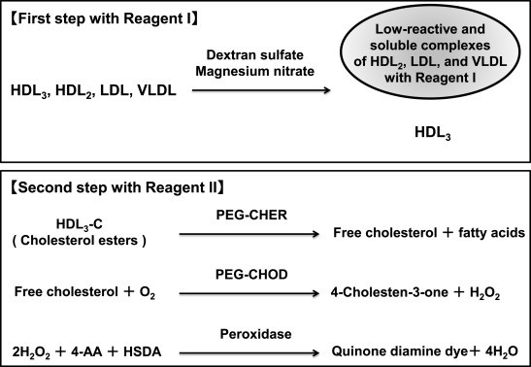

## Procedure:

|  |  |  |  |
| --- | --- | --- | --- |
|  | Blank | Standard | Sample |
| HDL cholesterol reagent |  |  |  |
| Blank |  |  |  |
| Standard |  |  |  |
| Sample |  |  |  |

**Calculation:**

O.D. of Standard =

O.D. of Test = Standard Concentration =

[ O.D. of Test ] - [ O.D. of Blank ]

Sample HDL conc. = ----------------------------------------- X Std.Conc.

[O.D. of Std. ] - [ O.D. of Blank ]

Your result. =

## Comment on your result:

**Reference Ranges:**

Male: >45 mg/dl

Female: >55 mg/dl

## Questions:

1. Name the Biologically active compounds synthesized from cholesterol
2. Mention the risk factors for Coronary Artery Syndrome.
3. Why Cholesterol level in serum increases in Nephrotic Syndrome and Obstructive Jaundice.
4. Why is HDL cholesterol called good cholesterol?
5. What is tangier’s disease?
6. Name some Cholesterol lowering drugs. Explain their mechanism of action.
   1. **Estimation of serum calcium (BI11.11)**

## Principle:

Calcium combines specifically with Arsenazo III at Neutral pH to form a blue colored complex. Intensity of the color formed is directly proportional to the amount of calcium present in the sample.

Calcium + Arsenazo III  Blue Purple coloured complex

## Procedure:

|  |  |  |  |
| --- | --- | --- | --- |
| **Reagents** | **Blank** | **Standard** | **Test** |
| Water |  |  |  |
| TG Standard |  |  |  |
| Serum |  |  |  |
| Reagent |  |  |  |
| Mix, incubate at RT for 5 min. Read absorbance at 578 nm | | | |

|  |  |  |
| --- | --- | --- |
| **Calculation:**  O.D. of Blank | = |  |
| O.D. of Standard | = |  |
| O.D. of Test | = |  |

Calcium Standard Concentration =

[ O.D. of Test ] - [ O.D. of Blank ]

Sample Calcium conc. = ----------------------------------------- X Std.Conc.

[O.D. of Std. ] - [ O.D. of Blank ]

**Your result**. =

**Reference Ranges:** Serum calcium = 8.5 to 10.5 mg/dl

**Comment on your result**

**Interpretation**

**Causes of Hypocalcemia.**

* 1. Hyperparathyroidism
  2. Cancers, especially lung and breast cancer
  3. Paget’s disease
  4. Kidney failure (Sarcoidosis)
  5. Hyperthyroidism
  6. Excessive vitamin D, excessive dietary calcium.
  7. Immobilization over a long period of time
  8. Medications such as the thiazide diuretics

## Causes of Hypocalcemia.

1. Malnutrition and malabsorption
2. Low levels of Vitamin D
3. Pancreatitis
4. Renal failure in advance stage
5. Hypermagnesemia and hyperphosphatemia
6. Massive transfusion of citrated blood
7. Medications, such phenytoin, phenobarbital, rifampin, corticosteroids, drugs used to treat elevated calcium levels and certain chemotherapy drugs.

## Questions

1. What is the normal total serum calcium level?
2. What is plasma ionized calcium?
3. What are the biochemical roles of calcium?
4. What is tetany?
5. What is RDA for calcium?

# Estimation of phosphorus (BI11.11)

## Principle (Phosphomolybdate Method):

Inorganic phosphorus reacts with ammonium molybdate in an acidic medium to form a phosphomolybdate complex. Intensity of the color formed is directly proportional to the amount of calcium present in the sample.

Phosphorus + Ammonium molybdate > Phosphomolybdate complex

## Procedure:

|  |  |  |  |
| --- | --- | --- | --- |
| **Reagents** | **Blank** | **Standard** | **Test** |
| Water |  |  |  |
| TG Standard |  |  |  |
| Serum |  |  |  |
| Reagent |  |  |  |
| Mix, incubate at RT for 10 min. Read absorbance at 340 nm | | | |

|  |  |  |
| --- | --- | --- |
| **Calculation:**  O.D. of Blank | = |  |
| O.D. of Standard | = |  |
| O.D. of Test | = |  |

Phosphorus Standard Concentration =

[ O.D. of Test ] - [ O.D. of Blank ]

Sample Phosphorus conc. = ----------------------------------------- X Std.Conc. [O.D. of Std. ] - [ O.D. of Blank ]

Serum Phosphorus concentration. =

**Reference Ranges:** Serum Phosphorus= 2.5 to 4.5 mg/dl

**Comment on your result:**

**Interpretation:**

* **Causes of High Phosphorus level;**
  + Chronic renal failure
  + Bone Metastases
  + High vitamin D levels
  + Hyperparathyroidism

## Causes of Low Phosphorus level;

* + - Hypervitaminosis due to Excessive Vitamin D
    - Primary Hyperparathyroidism
    - Renal Tubular Disorders
    - Antacids
    - Malabsorption

## Questions:

1. What is the normal range of Serum Inorganic Phosphorus?
2. What precautions must be observed for Serum Phosphorus estimation?
3. Mention the Relationship of Urinary Excretion of Calcium and Phosphorus with clinical Conditions.
4. Mention the causes of Hypophosphatemia and Hyperphosphatemia.

## Preparation of buffers and estimation of pH. (BI 11.2)

**Introduction**

pH is defined as concentration of hydrogen ions in the solution. expressed as pH **=** -log [H+].Pure water has pH nearly equivalent to 7 which is considered as neutral pH. solutions having pH greater than 7(pH >7) are considered as basic, whereas those lower than 7 (pH < 7 ) are called acidic.

## Buffers

A significant change in pH can lead to harmful reactions to molecular structure, biological activity and function. Protein structure can be disrupted, and enzymes denatured due to the effects of pH on cellular structure.

Buffers are aqueous systems that resist changes in pH as acid or base is added.

They are usually composed of a weak acid and its conjugate base If an acid is added to an unbuffered solution, the pH will change suddenly and proportional to the amount of acid added. However, the pH will drop gradually in buffer solution when acid is added. Buffers also mitigate the pH increase caused by adding base.

## Henderson-Hasselbalch Equation

The equilibrium constant for the deprotonation of an acid is written as:

*◻◻*[*◻*]+[*◻*]− 1

[*◻◻*]

*◻◻*

Where is [A-] the concentration of a conjugate base and [HA] is the concentration of an acid, Taking logarithms of both sides, we get

*◻◻* − *◻◻◻*[*◻*]+ − *◻◻◻*  [*◻*]− 2

[*◻◻*]

by subtracting both sides by *log* [A - ]/ [HA] we get

*◻◻*

[*◻*]−

*◻◻* = *◻◻◻* + *◻◻◻* [*◻◻*]

This is the Henderson-Hasselbalch Equation. It describes the dissociation of a weak acid (HA) in the presence of its conjugate base (A-).

The midpoint of the buffering region is when one half of the acid reacts to dissociation and where the concentration of the proton donor (acid) equals that of the proton acceptor (base); the pH of the equimolar solution of acid is equal to the pKa. (When the concentration ratio for conjugate base and weak acid, [A-]/[HA], is 1:1

## pH of various body Fluids

|  |  |
| --- | --- |
| **Name of body Fluid** | **pH** |
| 1) CSF | 7.3 |
| 2) Blood | 7.38-7.42 |
| 3) Gastric juice | 1.5-3.5 |
| 4) Lymph | Same as plasma |
| 5) Seminal fluid | 7.1-8.0 |
| 6) Bile | 7.5-8.8 |

**Method of pH measurement**

pH can be measured either by using pH papers that give subjective, but not precise pH range or with the help of a pH meter that gives precise pH measurement. The normal H+ ion concentration in terms of gms/l is in the range of 10-1 to 10-14.

For simplicity, the term pH = -log [H+].

## Principle

pH meter is based on the principle of potentiometry i.e measurement of EMF(emf) generated between two electrodes of electrochemical cells due to difference in[H+] concentration.

If a metal plate (Iron plate) is placed in a solution of salt of the same metal (ferrous sulfate) then metal loses ions into the solution and metal (iron) itself becomes negatively charged (Fe+3) as compared to the solution. This generates an electrical potential on the metal plate or the electrode.

So, when two different metal electrodes are connected in this way, the difference in their electrode potential can be measured as e.m.f. (electromotive force) hence, one of the electrodes is a standard Electrode, then electrode potential of the other can be measured by comparison. The electrochemical cell consists of two metal electrodes each of which is dipped into suitable but different solutions connected by wire. The circuit is completed by a potassium chloride /agar bridge between two liquids. Each metal plate **+** the electrode and the solution in which it is immersed constitute a **half-cell**. If one of the half cells is arbitrarily assigned a fixed potential, then the potential of the other half cell may be determined relative to it. The potential of an electrode, which remains fixed, is called a standard electrode. The other electrode is called a measuring electrode. The e.m,f. is defined as the maximum potential difference between two electrodes, when the cell current is zero.

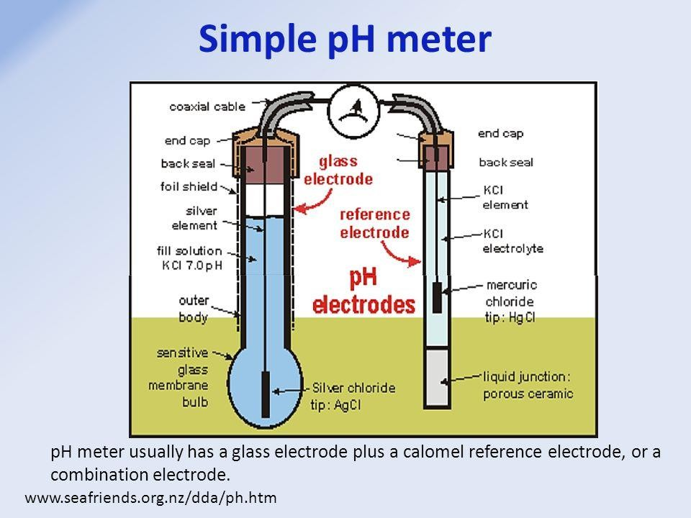

## Applications:

* To measure pH of biological fluids.
* To adjust the pH of buffer solution which are used in enzyme assays & electrophoretic separation of bio - analytes.
* To adjust the pH of various reagents used in biochemical assays.

Clinical application includes measurement of pH of blood gases, CO2, O2 & bicarbonate using blood gas analyzer.

## Questions:

1. Why is maintenance of pH of Blood & Body fluid a vital need?

* 1. **Arterial Blood gas analyzer (BI 11.16)**
* The Arterial Blood Gas (ABG) is a blood test that is performed using blood from an artery.
* The ABG is a test that measures the Partial Pressure of Oxygen (Po.), Partial Pressure of Carbon Dioxide (PCO) and Acidity (pH) of Arterial Blood. In addition, arterial Oxyhemoglobin Saturation can also be determined.
* ABG testing is mainly used in critical-care medicine to determine gas exchange across the alveolar- capillary membrane. Therefore, the ABG test is one of the most common tests performed on patients in intensive-care units. ABG testing also has a variety of applications in other areas of medicine.
* ABG samples originally were sent from the clinic to the medical laboratory for analysis. Newer equipment lets the analysis be done also as point-of-care testing.

**Sampling-Protocol:**

* It involves puncturing an artery with a thin needle and syringe and drawing a small volume of blood.
* The most common puncture site is the Radial Artery at the wrist because it is easily accessible, can be compressed to control bleeding, and has less risk for vascular occlusion.,
* The brachial artery (or less often, the femoral artery) is also used, especially during emergency situations or with children. Blood can also be taken from an arterial catheter already placed in one of these arteries.
* The plastic and glass syringes are used for blood gas samples. Most syringes come pre-packaged and contain a small amount of Heparin, to prevent coagulation. Other syringes need to be heparinized, by drawing up a small amount of liquid Heparin and squirting it out again to remove air bubbles.
* Once the sample is obtained, care is taken to eliminate visible gas bubbles, as these bubbles can dissolve into the sample and cause inaccurate results. The sealed syringe is taken to the Laboratory for blood gas analysis.
* After collection of blood sample in heparinized syringe, the transportation & analysis of the sample should be completed within 30 Minutes at room temperature. If prolonged time delays are expected (i.e., greater than 30 min) prior to analysis, the sample should be drawn in a glass syringe (not in plastic blood gas syringe) and immediately placed on ice.

**Analysis-Protocol:**

* The sealed syringe is then taken to a blood gas analyzer which aspirates the syringe and runs whole blood through a chamber equipped with an ion selective electrode (i.e. the selectivity can be adjusted for specific measurements).
* pH is assessed by comparing a potential generated at the tip of the electrode with a reference potential. The resulting voltage is proportional to the hydrogen ion concentration [H].
* PCO₂ is also measured using a pH electrode tip covered by a semipermeable membrane that is selective for CO₂. The CO₂ binds with water in the free space between the membrane and the electrode and produces an amount of hydrogen ions that is proportional to the content of CO, in the blood sample (PCO₂). Since the voltmeter is actually measuring hydrogen ion content, it is calibrated as reading PCO₂.
* PO₂ similarly to pCO₂ is measured by employing a selectively permeable membrane that allows it to pass through and bind to water in a phosphate buffer on the other side. The amount that passes through is equivalent to the pO, in the blood sample .
* Finally the blood sample is disposed of, the machine washes out the blood and results are displayed and evaluated.

**Parameters & Reference Ranges:**

1. **Analyte: pH / H+**

Range: 7.34-7.44/35-45 nmol/L (nM) Interpretation

Acidosis: pH<7.35 or H+>45 nmol/L Alkalosis: pH>7.45 or H+ <35 nmol/L

1. **Analyte: HCO3-**

Range: 22-26 mEq/L Interpretation:

Bicarbonate is a weak base that is regulated by the kidneys as part of acid-base homeostasis.

A low Bicarbonate indicates Metabolic Acidosis high Bicarbonate Indicates Metabolic Alkalosis.

As this value when given with blood gas results is often calculated by the analyzer.

1. **Analyte: Partial Pressure-Arterial carbon dioxide (PCO₂)**

Range: 35-45 mmHg Interpretation:

The Partial Pressure of Carbon Dioxide (PCO₂) is an indicator of CO₂, production & its elimination during normal or constant metabolic rate. The PCO₂ is determined entirely by its elimination through alveolar ventilation.

A low pH with a high PCO₂ suggests Respiratory Acidosis, alternatively Hypercapnia due to under ventilation (or, more rarely, a Hypermetabolic Disorder).

A low pH with a low PCO₂ suggests Respiratory Alkalosis, alternatively Hypocapnia due to Hyper-or over ventilation-Stimulation of Respiratory center in Brain.

1. **Analyte: Partial Pressure-Arterial oxygen (PO₂)**

Range: 75-100 mmHg Interpretation:

The state of arterial blood oxygenation is determined by the PO₂, This reflects gas

Exchange in the lungs and normally the PO₂, decreases with age. This is due to decreased elastic recoil in the lungs in the elderly, thereby yielding a greater ventilation-perfusion mismatch.

A low PO₂ indicates that the patient's Blood is not properly oxygenating and is Hypoxemic. This can result from hypoventilation or a mismatch of ventilation and perfusion. At a PO₂ of less than 60 mm Hg. supplemental oxygen should be administered. At a PO₂ of less than 26 mmHg, the patient is at risk of death and must be oxygenated immediately.

1. **Analyte: Anion Gap**

Range: 8-16 mmol/L

Anion Gap = (Na +K)-(Сl+НСО3) Interpretation

It's an indicator of unmeasured anion.

A raised anion gap indicates an increased concentration of lactate, ketone bodies, and renal acids, salicylate poisoning, amino or organic aciduria.

A normal anion gap is seen if a Metabolic Acidosis is due to Diarrhea or Urinary Loss of Bicarbonate, CA inhibitors, RTA type I, II and IV.

Anion Gap decreases with Hypoalbuminemia, Multiple myeloma, Hypercalcemia and Bromide intoxication.

1. **Analyte: Base excess** Range: -2 to +2 mmol/L Interpretation:

The metabolic component of the acid-base balance is reflected in the base excess. This is a calculated value derived from blood pH and PCO₂ It is defined as the amount of acid

required to restore a liter of blood to its normal pH at a PCO₂ of 40 mmHg.

The base excess increases in metabolic alkalosis and decreases in metabolic acidosis.

**Clinical significance:**

* + Blood gas tests can be used in the diagnosis of a number of acidosis conditions such as metabolic and respiratory acidosis and also of respiratory alkalosis. Particularly, umbilical cord blood gas analysis can give an indication of preceding fetal hypoxic stress. In combination with other clinical information, normal paired arterial and venous cord blood gas results can usually provide a robust defense against a suggestion that an infant had an intrapartum hypoxic-ischemic event.
  + Abnormal results may be due to a wide range of diseases, including poisoning and trauma as well as lung, kidney, or metabolic diseases. Head or neck injuries or other injuries that affect breathing can also lead to abnormal results.

**Questions:**

1. Write Biological Reference range of various Blood Gas Parameters like PCO₂, PO₂, pH, HCO3.
2. Mention various disorders due to Acid Base Disturbance with Examples.
3. What is Anion Gap & its Importance?
   1. **Chromatography (BI 11.16, BI 11.19)**
   2. **Electrophoresis (BI 11.16, BI 11.19)**
   3. **ELISA (BI 11.16, 11.19)**
   4. **Screening of urine for Inborn errors of metabolism (BI 11.5)**

Inborn errors of metabolism (IEM) are disorders in which there is a block at some point in the normal metabolic pathway caused by a genetic defect of a specific enzyme.

**Why newborn screening?**

* LEM presentations are not straight-forward and often critical. Initial symptoms are extremely non-specific Metabolic acidosis with anion gap, transaminases, glucose, ammonia.
* Untreated individuals have significant morbidity and/or mortality.
* Early treatment improves everything: length and quality of life & Financial burden.

**List of inborn metabolic disorders Carbohydrate metabolism**

* Galactosemic produces cataracts and severe liver disease; the other members of this group usually present with a combination of hypoglycemia and lactic acidosis

Galactosaemia - Galactose-1-phosphate uridyl transferase

Hereditary fructose intolerance requires a fructose load before symptoms appear

* Glycogen storage disease - type 1 Glucose 6 phosphatases Lactic acidosis - Pyruvate carboxylase

**Amino acid disorders:**

* + Presentation may be variable, but central nervous system dysfunction is common.
  + In maple syrup urine disease, the urine has a characteristic odor.
  + Acute hereditary tyrosinemia causes severe liver disease and renal tubular dysfunction.
  + Maple syrup urine disease - Branched chain keto acid decarboxylase
  + Tyrosinaemia type I-Fumaryl acetoacetase

**Organic acid defects:**

* + Present with a combination of lethargy, seizures, ketoacidosis, neutropenia, hyperammonemia, and hyperglycinemia. Hypoglycemia is common.
  + Isovaleric acidemia and glutaric aciduria type II produce a specific odor of 'sweaty feet.
  + Methylmalonic acidaemia - Methylmalonyl coenzyme A mutase
  + Propionic acidaemia - Propionyl coenzyme A carboxylase
  + Isovaleric acidaemia - Isovaleryl coenzyme A dehydrogenase

**Urea cycle defects and hyperammonemia:**

* + Citrullinaemia - Argininosuccinic acid synthetase
  + Argininosuccinic aciduria - Argininosuccinic acid lyase
  + Argininemia-Arginase

**Chemical tests:**

The following chemical tests are simple colorimetric procedures which use random urine specimens. Most of the tests are designed to screen for excess metabolites derived from elevated amino acids due to inborn errors of amino acid metabolism. Five chemical tests are routinely used to screen urine for inborn errors of amino acid metabolism.

1. **Ferric Chloride Test:**

A green color indicates positive for PKU. A fading green color indicates the presence of p hydroxyphenyl pyruvic acid for tyrosinemia. The test gives various colors with a variety of drugs including a purple color with salicylates.

1. **2,4-Dinitrophenylhydrazine (DNPH) Test:**

The appearance of a yellow precipitate 10 min after the addition of DNPH reagent indicates the presence of excess alpha-keto acids. A positive DNPH test confirms the diagnosis of PKU by ferric chloride test. A greenish gray color suggests maple syrup urine disease.

1. **Nitrosonaphthol Test (Millon Reaction):**

The appearance of an orange-red color indicates the presence of excessive amounts of tyrosine derivatives.

1. **Cyanide-nitroprusside Test:**

The appearance of a magenta color indicates the presence of excessive cystine, or homocysteine, or P- mercaptoacetate-cysteine disulfide.

1. **Silver-nitroprusside Test:**

The appearance of a magenta color indicates the presence of homocysteine. It is used to differentiate between homocysteine and cysteine when there is a positive reaction in the cyanide-nitroprusside test.

1. **Benedict's test:**

These screening tests are sensitive, but not specific. so, positive results should be confirmed by more definitive assays for amino acids, such as HPLC.

**Investigations:**

first line investigations (metabolic screen): The following tests should be obtained in ALL babies with IEM.

* + Complete blood count with differential
  + Arterial blood gases and electrolytes
  + Blood glucose
  + Plasma ammonia (Normal values in newborn: 90-150 µg/dl)
  + Plasma lactate
  + Liver function tests
  + Urinalysis: Urine ketones, Urine reducing substances.
  + Serum uric acid (low in molybdenum cofactor deficiency),
  + Plasma and urine amino acids, quantitative analysis

# Autoanalyzer

* 1. **Quality control in clinical chemistry laboratory**

## Calculate energy content of different food Items, identify food items with high and low glycemic index and explain the importance of these in the diet (BI11.23)

**What is the Glycemic Index (GI)?**

* The GI is a ranking of carbohydrate foods from 0 to 100 based on how quickly and how much they raise blood sugar levels after being eaten. This is related to how quickly a carbohydrate containing food is broken down into glucose.
* Low GI foods produce a slower, lower rise in blood sugar levels.
* High GI foods produce a faster, higher rise in blood sugar levels.
* Low GI foods have a GI of less than 55
* Medium GI foods have a GI between 55 and 70
* High GI foods have a GI greater than 70

## Why is the GI important?

* Considering the GI of carbohydrate foods can help with good diabetes management as:
* Lower GI foods produce lower, more stable blood sugar levels and therefore, it can help improve control of diabetes.
* Higher GI foods produce higher, faster rising blood sugar levels.
* Lower GI foods also help you to feel fuller for longer, which can help to control appetite and assist with weight management.

## Factors affecting the GI of foods

* There are many factors that have an effect on the GI of carbohydrate
* containing foods:
* The type of starch present
* The type of sugar present - fructose (fruit sugar) and lactose (milk sugar) both have a lower GI than sucrose (table sugar)
* The amount of water-soluble fiber. The more soluble fiber a food contains, the lower the GI value.
* Storage time and ripeness will affect the GI value; the more ripe a fruit or vegetable is, the higher the GI value.
* Cooking and processing food will usually increase the GI as there is less work required by the body to break the carbohydrates down. For example, juice has a higher GI value than whole fruits.
* Adding acidity to the food will lower the GI (e.g. adding lemon juice).
* Fat and protein consumed in the same meal will decrease the GI of a food or meal.

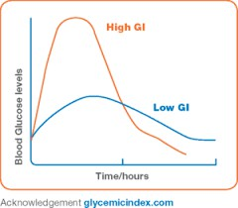

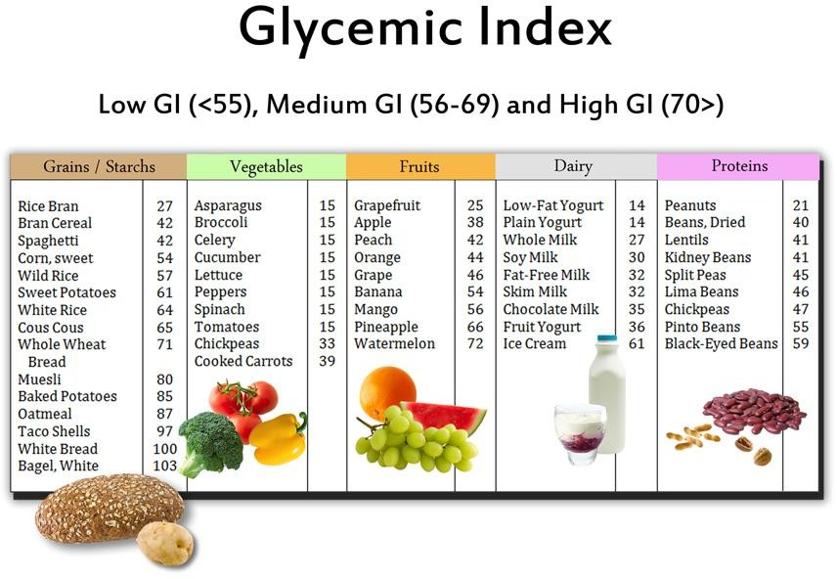

## Remember, GI is not a reflection of how healthy a food is.

* Fat content - Foods high in fat often have a low GI (e.g. chocolate or corn chips) and should only be included occasionally.
* The amount of food eaten- a small amount of a high GI food e.g. watermelon may only have a small effect on blood sugar levels.
* The quality of food- always aim to eat a wide range of carbohydrate-containing foods including wholegrain breads and cereals, fresh fruit and vegetables and dairy which provide important nutrients and fiber.

## What is the Glycemic load?

* The glycemic load (GL) is an equation that takes into account the planned portion size of a food as well as the glycemic index of that food.
* Glycemic Load = GI/100 multiplied by the net grams of planned carbohydrate (net carbohydrate is the total grams of carbohydrate minus the dietary fiber)

## Calculate energy content of different food Items

Some diet components that provide little or no food energy, such as water, minerals, vitamins, cholesterol and insoluble fiber, may still be necessary to health and survival for other reasons. Water, minerals, vitamins, and cholesterol are not broken down (they are used by the body in the form in which they are absorbed) and so cannot be used for energy.

## The Atwater general factor system

It uses a single factor for each of the energy-yielding substrates like protein, fat, carbohydrate, regardless of the food in which it is found.

* 17 kJ/g (4.0 kcal/g) for protein,
* 37 kJ/g (9.0 kcal/g) for fat
* 17 kJ/g (4.0 kcal/g) for carbohydrates

o kJ/g (2.0 kcal/g) for dietary fibre

* 29 kJ/g [7.0 kcal/g]) for alcohol
* 13 kJ/g [3.0 kcal/g for organic acids
* 10k J/g (2.4 kcal/g for polyols

## Let’s take a fictional food label, which says the following,

Per 100g 170 Calories

10 g sugar(10 x 4= 40 kcal/gm)

10 g fat(10 x 9= 90 kcal/gm)

10 g protein(10 x 4= 40 kcal/gm)

1 g salt

1 g fiber

This gives us a total of 170 calories per 100 grams. So, 10 grams multiplied by 9 is 90 calories. 90 calories divided by 170 calories is 0.53. Multiplied by 100 is 53. This means the product is 53% fat

## Exercise

Given below is the information on label of food item Calculate total calories obtained from one serving of 70 grams of this food item.

|  |  |
| --- | --- |
| Fat 15% | Carbohydrate 4% |
| Protein 3% | Vitamin 3% |
| Cholesterol 0.01% | Fiber 0.01% |

# Discussion on advantages and/or disadvantages of use of unsaturated, saturated fatty acids (BI11.24)

## Unsaturated fats

Resemble saturated fatty acids, except that the chain has one or more double-bonds. The two carbon atoms in the chain that are bound next to either side of the double bond can occur in a cis or trans configuration.

## Saturated fats

long-chain carboxylic acids that usually have between 12 and 24 carbon atoms and have no double bonds.

Sources of saturated fats : High fat cheeses, meat, whole fat milk and cream, butter, Ice cream and ice cream products, palm and coconut oil.

## Trans-fats Introduction

All the fatty acids that are found in human body are cis fatty acids, with the exception of retinoic acid (which is present in the eye). If meats or fish are left outside exposed to air, they eventually start to reek. This is partly due to the oxidation of single bonds in the fatty acids, which turns them rancid and is responsible for the bad odor. However, if they are saturated fats without single bonds, they do not smell.

Fatty acids with cis double bonds are liquids, although hydrogenation can turn them into solids by turning them into saturated fatty acids. Cis fatty acids have "kinks" in them and hence do not pack well, so they remain in a liquid state at lower temperatures. The methods of hydrogenation of fats were used to hydrogenate dietary fatty acids such as soybean oils because hydrogenated oils do not go rancid and smell.

The process of hydrogenation as below

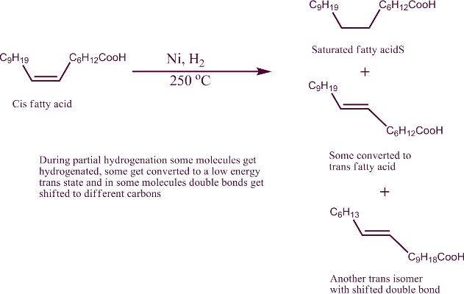

The double bonds get saturated. However all the double bonds do not get saturated. And at that high temperature some of the double bonds seem to migrate to other carbons in the chain. Formation of trans configuration is more stable than cis. In that process at the newer position, they become trans double bond. Cis configuration has more strain in it than trans. As it is seen on the packet ingredient list, they are written as “partially hydrogenated".

## Why are partially hydrogenated or trans fats bad for health?

As mentioned above, our body mostly contains cis fatty acids. Whether our cells make them or they are from natural diet sources, they are all of cis configuration. Since all the natural fats are cis, the cellular enzymes have active sites that preferentially metabolize cis fatty acids. So over several years, trans fats accumulate in the body over those of cis form. Since all the natural fatty acids are cis, the enzymes that synthesize triglycerides and the enzymes that breakdown fats for energy, may not work efficiently. If they are not natural molecules, the cell’s enzymes can’t either break them or break them inefficiently. In addition as the trans fats accumulate in the body, as they are similar in structure to cis

fats (to an extent) they mat act as competitive inhibitors to fatty acid metabolizing enzymes.

In addition, when natural cis fatty acids are incorporated into the cell membranes, as they have cis configuration, they do not pack very compact thus giving fluidity to the cell membrane. If membranes contain trans fats in them, the membrane fluidity will be affected. It is also likely that membrane receptor function will also be affected. If the Trans fatty acids are incorporated into erythrocyte membranes, the membranes would be more rigid and erythrocytes would break as they travel through the microcapillaries.

# Case study of Gout (BI11.17)

A 50-year-old male chronic alcoholic presented in the OPD with severe pain along with erythema and swelling in the right big toe, but all other major joints (hip, ankle, shoulder, and wrist) are normal. He said that he had heavily consumed alcohol last night. On examination, the affected area was tender, swollen and warm. Also history was there of increased pain during winter. High serum uric acid level is found in investigation.

Physician diagnosed this patient as Gouty Arthritis. Physician asked patient to take Allopurinol with NSAID drug as well as to restrict alcohol and non-vegetarian foods.

1. Explain the biochemical basis of the gout.
2. Mention the primary and secondary causes of this disease.
3. Explain the relationship between alcohol consumption and onset of acute attack of pain.
4. Write the biochemical role of Allopurinol in this case?
5. Write the biochemical role of NSAID in this case?
6. Write biochemical role of Probenecid (Uricosuric drug).
7. Write biochemical role of Fasturtec (Uricase analogue) in the gout.
8. Write a biochemical role of restricting non-vegetarian food.
9. Write a biochemical role of restricting alcohol intake.
10. Why does gouty arthritis cause pain and swelling in distal joints like joints of fingers and toes
11. Why do clinical features of gouty arthritis increase during winter?
12. What are the renal complications of gout?

# Case Study of DKA (BI11.17)

A 14 year old boy came into an emergency with an altered consciousness level and increased respiratory rate (Tachypnea) for the last 4 hours. There is a fruity smell in breath. Patient's relative is telling that he is also having complaints of weakness and decreased urine output for the last 2 days.

On General examination, physician noted

* Dryness of mouth
* Pale & dry conjunctive
* Shrunken eyeball.
* Low volume pulse
* Tachypnea (increase respiratory rate)
* Tachycardia (increase heart rate)
* Very low blood pressure (70/40 mm Hg).

Doctor made an admission in the ICU and asked immediately for blood investigation.

* Random blood glucose = 510 mg/dL
* Glycated hemoglobin = 10%
* pH=7.1
* pCo2- 28 mmHg
* Plasma HCO3- = 12 mEq/L,
* Serum Sodium-120 mEq/L
* Serum Potassium-6.2 mEq/L
* Urine for reducing = Positive
* Urine For Ketone Body = Positive

Patient is Diagnosed as “Diabetic ketoacidosis with severe dehydration” Advised to following treatment.

* Inj normal saline fast I.V.
* Inj Human Insulin injection
* Inj Bicarbonate
* K+ Binding resin Sachets Orally.

1. Give explanation for altered consciousness and increase respiratory rate in this case.
2. What is the cause of fruity odor in breath?
3. Give explanation for Positive Ketone Body in urine.
4. What is patho-physiology behind decreased urine output in this patient?
5. Give comment on patient ABG report.
6. Give biochemical reasons for increase K+ level in this case.
7. How bicarbonate, insulin and K+ binding resin reduce serum potassium level?
8. Why is potassium supplementation needed during correction of DKA?
9. What is the cause of fruity odor in breath?
10. Write the significance of Glycated hemoglobin levels.
11. What is the biochemical reason for severe dehydration in this case?
12. What could be a type of diabetes mellitus and how to confirm it?
13. Write Diagnostic criteria for Diabetes mellitus.

# Case Study of DM (BI11.17)

A 54 year obese female presented to OPD with complaints of recurrent infection, weakness & lethargy for the last 3 months. History was revealed that patient has increased appetite, increased thirst and Nocturia(increased frequency of urination in night) Laboratory investigation

* Fasting blood glucose - 180 mg/dL
* Post Prandial blood glucose- 280 mg/dL
* Glycated hemoglobin - 9.5%
* Total Cholesterol-300 mg/dL
* Triglyceride- 230 mg/dL
* Urine examination for reducing sugar

-Positive

With provisional diagnosis of uncontrolled type 2 diabetes mellitus, Physician started antibiotics for 7 days, statin group of drugs with oral hypoglycemic drugs for diabetes mellitus and advised patient to take more fruits and green leafy vegetables in diet and advised the patient to come after one week with following reports.

Serum Creatinine, Urine Protein, FBS, PP2BS, and C peptide.

1. Give explanation for recurrent infection in this case.
2. Give explanation for weakness & lethargy.
3. Give explanation for increased thirst and nocturia in this patient.
4. Give explanation for raised Glycated hemoglobin in this case.
5. Why Cholesterol is elevated in this patient?
6. Why is reducing sugar present in the urine sample of this patient?
7. What are the diagnostic criteria for Diabetes mellitus?
8. Why did the physician prescribe fruits and green leafy vegetables in the diet?
9. Why serum Creatinine and urine protein is advised in this case?
10. What investigation is needed to confirm the type of diabetes mellitus?
11. What is the significance of asking for c peptide investigation in this case?
12. Explain the biochemical basis of type 2 Diabetes mellitus.
13. What are the possible complications if the blood sugar is not controlled?

# Case Study of Myocardial Infarction (BI11.17)

Early in the morning, a 40 year old male patient came into the emergency with complaining of chest pain with perspiration for 6 hours. Patient also had diabetes mellitus for 10 years. He was taking medicine for diabetes mellitus irregularly. In history, it was found that he was a chronic alcoholic. Doctor asked for a few blood investigations. From ECG finding and abnormal cardiac function test diagnosis of myocardial infarction was confirmed.

Investigation

* Random Blood Sugar = 250 mg%
* HbA1C = 9 %
* S. Cholesterol = 350 mg%
* S. Triglyceride = 250 mg%
* S. HDL Cholesterol = 25 mg%

Physician advice to admit patient in ICU and to start following treatment

* Aspirin (anti-platelet drug)
* Atorvastatin(Statin group drug)
* Tablet Nitroglycerine(Vasodilator)
* Streptokinase (Fibrinolytic drug)

At time of discharge from hospital, physician advised to take more amounts of fruit and fiber food, and Lifestyle modifications.

1. Why uncontrolled diabetic mellitus increases chances of atherosclerosis?
2. Which test will you prefer to do for diagnosis of myocardial infarction, if a patient comes after 4 days of onset of chest pain?
3. How does a statin group of drugs reduce cholesterol level?
4. What is the role of fruits and fiber in chronic diabetes mellitus and atherosclerosis?
5. How will you calculate a patient's LDL and VLDL cholesterol?
6. What is the role of fibrinolytic drugs (streptokinase) in myocardial infarction?
7. What is the mechanism of aspirin?
8. What is the reason for chest pain in case of myocardial infarction?
9. How do chances of hypercholesterolemia increase in patients of chronic alcoholism?
10. What is the significance of higher HbA1c in this patient?

# Case Study of of myocardial infarction (BI11.17)

Early in the morning, a 22 years old male patient came into the emergency room complaining of chest pain with perspiration for 45 minutes. He was rushed to the hospital where ECG was performed. From ECG finding diagnosis of myocardial infarction was made. Immediately Blood sample was sent for laboratory investigations. Physician advice to admit patient in ICU and to start following treatment

* Aspirin (anti-platelet drug)
* Atorvastatin( Statin group drug)
* Tablet Nitroglycerine(Vasodilator)
* Streptokinase (Fibrinolytic drug)

Following is the Blood investigations report.

* CKMB=23 IU/L(5-25)
* Troponin I=17 pg/ml(<20)
* Random Blood Sugar = 93 mg%
* S. Cholesterol = 220 mg%
* S. Triglyceride = 160 mg%
* S. HDL Cholesterol = 40 mg%
* S. Homocysteine= 180 micromole/L(5-15)
* S. Lipoprotein(a)=28 ng/dl(<30)

Physician advised me to take multivitamin tablets (Vit B12, Folic acid, Pyridoxine), more amounts of fruit and fibers, and Lifestyle modifications.

* 1. Explain the biochemical basis of chest pain.
  2. Why does an ECG change not correlate with lab investigations CKMB and Troponin?
  3. What are other laboratory ingestions that should be performed in this case?
  4. Why elevated Homocysteine level is associated with Myocardial infarction in young age?
  5. What is the reason for advising Lipoprotein (a) in this case?
  6. What is the reperfusion injury?
  7. Explain the role of Allopurinol in the treatment of reperfusion injury.
  8. Why did the physician prescribe Vit B12, Folic acid & Pyridoxine to this patient?

# Case study of Chronic Kidney Disease

A 57-year-old male presented to a hospital with a 4-day history of Decreased urine output for 2 days, coughing, vomiting, headache, facial edema, and lower extremity cramping.

He is giving the history of diabetes since 15 years and hypertension since 5 years for which he is taking antidiabetic and antihypertensive treatment. His blood pressure is 170/100 mm Hg. On examination respiratory distress with nasal flaring, bilateral periorbital edema, and bilateral lower extremity edema were present. Physician advised laboratory investigations and admission in intensive care unit for further evaluation and treatment. Physician also advised for fundoscopic retinal examination. Following are the Laboratory investigations of this patient.

* Fasting blood Glucose- 260 mg/dl
* HbA1C- 8.5%
* Serum Creatinine- 9.5 mg/dl
* Serum Urea- 185 mg/dl
* Serum sodium-123 mEq/L
* Serum Potassium- 6.5 mEq/L
* Serum Phosphate- 11 mg/dl
* Serum Calcium- 5.3 mg/dl
* Hemoglobin-5.5 g/dl
* Parathyroid hormone- 682 pg/ml (11-

80)

* Vitamin D-
* Urinary protein-
* GFR- 55 mi/minute/1.73m 2

Chest X-ray was significant for cardiomegaly and pulmonary edema. Renal ultrasound revealed Bilateral small kidneys. He is diagnosed as a CKD. Patient emergently underwent hemodialysis for fluid overload and to correct electrolyte imbalance. His anemia and electrolyte imbalances were slowly corrected. He is currently transitioned to peritoneal dialysis awaiting kidney transplant.

1. What could be the reason for the Chronic Kidney disease in this case?
2. What is the reason for the Facial edema and edema on both the lower limbs?
3. Give the biochemical explanation for elevated serum Urea and Creatinine.
4. What is the reason for Hyponatremia and hyperkalemia?
5. Give the biochemical explanation for hypocalcaemia and hyperparathyroidism.
6. What is the reason for anemia in this case?
7. Why is this patient suffering from hypertension?
8. Why did the physician give advice for a fundoscopic examination?
9. Why is Creatinine the preferred marker for calculation of GFR?
10. Name the laboratory investigation utilized for early detection of diabetic nephropathy.

# Case Study of sickle cell anemia

A 14 years male child comes in an emergency with a complaint of Acute abdominal pain and Acute hip joint pain. Pediatrician examined the patient. He asked for ICU admission and for following investigation

* Hemoglobin 6.5 gm%
* Total Billi 3.4 mg%
* Direct Billirubin 0.8 mg%
* Indirect Billirubin 2.6 mg%
* S. ALP-950 IU/L
* S.LDH 2000 IU/L
* Peripheral Smear examination-Sickle shape RBC.

Pediatrician diagnosed the case as a Sickle cell crisis and ask to collect the blood sample for Hb electrophoresis for confirmation of diagnosis, before starting the following Treatment

* Oxygen inhalation
* Inj Normal Saline(Hydration)
* Inj Whole Blood
* Tab Hydroxyurea

1. What is molecular abnormality in sickle cell disease?
2. What is the reason for Acute abdominal and Hip joint pain?
3. What is the reason for decreased Hemoglobin in this case?
4. What is the type of jaundice in this case? Justify.
5. Explain biochemical reasons for High level of ALP and LDH.
6. What could be a pattern in Hb electrophoresis for differentiation of type of sickle cell anemia?
7. Why blood sample should be collected before blood transfusion for Hb electrophoresis?
8. What is a biochemical mechanism of using hydroxyurea in this case?
9. What is the biochemical significance of oxygen inhalation?
10. What is the biochemical significance of hydrating the patient?
11. How does this disease give protection against malaria?
12. Which is the screening test that can be performed at the Primary health center?
13. Name the confirmatory test for sickle cell disease.

# Case study of thalassemia

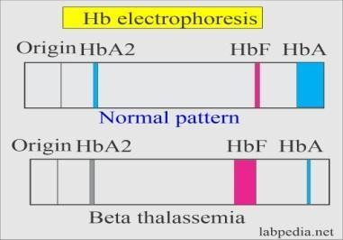A 3-year-old child was brought to the hospital with chief complaints of breathlessness, weakness, and failure to thrive. On examination, pallor and icterus was present as well as face having typical features like frontal bossing (protruded frontal bone), maxillary hypertrophy of thalassemia. Per abdomen examination showed presence of massive hepatosplenomegaly. Following are the laboratory and Hb Electrophoretic pattern of this patient.

Hb: 5.5 g/dL (11.6-16.6 g/dL)

Serum Total Bilirubin: 4.0 mg/dl Direct Bilirubin: 1.0 mg/dl Indirect Bilirubin: 3.0mg/dl

Physician advised to admit the child and start packed cell volume (Blood component with concentrated Red blood cell) and tablet desferrioxamine (chelating agent).

1. Give the biochemical explanation of frontal bossing and maxillary hypertrophy.
2. What is the reason for hepatosplenomegaly?
3. How does Hb electrophoresis pattern justify beta thalassemia?
4. Name the type of the jaundice in this patient and write reasons for the same.
5. What is the role of chelating agents in patients of repeated blood transfusion?
6. Why did the physician ask for blood transfusion instead of iron and vitamin B12 supplements to correct the anemia?
7. How to differentiate alpha and beta thalassemia based on electrophoretic pattern?
8. Which is the confirmatory test for the diagnosis of thalassemia?

# Case study of Glycogen storage disease

A 1-month-old boy brought to the OPD with frequent altered consciousness, frequent drowsiness and not responding to any verbal or stimulatory command, grossly enlarged abdomen. On physical examination massive hepatomegaly and there is no weight gain after birth. Following is the Blood investigations:

* Fasting blood glucose -40 mg/dL
* Serum Total Cholesterol -300 mg/dL
* Serum uric acid-12.8 mg/dL
* Serum SGPT- 250 u/l
* Blood pH-7.2
* Serum lactic acid-15 mg/dl
* Bicarbonate- 12mEq/L
* Serum Potassium- 6.2mEq/L
* Urine ketone bodies- +++

Pediatrician diagnosed this child as a Type 1 Glycogen storage disorder (Von Gierke disease). Pediatrician has started iv dextrose and bicarbonate. After complete recovery on discharge, the pediatrician frequently breastfeeds at every 2 hours.

1. Explain the biochemical basis of the Hypoglycemia in this child.
2. Explain the biochemical basis of the elevated cholesterol in this case.
3. Explain the biochemical basis of the raised Uric acid in this child.
4. What is the biochemical reason for raised SGPT?
5. What is the reason for decreased bicarbonate in this case?
6. Why is serum potassium elevated in this case?
7. Why urine examination shows positive Ketone bodies?
8. Why do pediatricians prescribe frequent breastfeeding every 2 hours?

# Case study of Portal Hypertension

A 56 year male patient came in emergency with alter-consciousness & haematemesis. He was suffering from chronic cirrhotic liver disease due to chronic alcoholism. On examination , it was found that he has edema on both lower limb, fluid collection in peritoneal cavity (Ascites), yellowish discoloration of skin & sclera (icterus), with hypotension (decrease Blood Pressure). On blood investigation the following was found.

* Blood Glucose : 50 mg%
* Serum Protein : 5.5 gm %
* Serum Albumin : 2.0 gm%
* Serum Ammonia : Very High
* Serum Total Billirubin : 20 mg%
* APTT – Test : 60 second

Physician advice to give following treatment

* Injection 10% Dextrose
* Injection Thiamine (B1)
* Injection Vitamin K
* Injection 10% Albumin
* APTT – Control : 30 second
* APTT – INR : 2
* Hemoglobin : 6 gm%
* Ultra Sono-Graphy detect Cirrhosis of Liver & Fatty Liver
* Oral Neomycin (Anti-microbial, Antibiotic)
* Liq Lactulose (Laxative)
* Oral Phenylbutyrate
  1. Biochemical explanation of altered consciousness in this case.
  2. Biochemical explanation of Haematemesis in this case.
  3. Biochemical explanation of Ascites in chronic alcoholic patients.
  4. Why Ammonia is raised in this case?
  5. Biochemical explanation of Hypotension in this case.
  6. What is hepato-renal syndrome?
  7. Biochemical reason for giving Dextrose plus thiamine in this patient.
  8. Biochemical reason for giving Vitamin K in this patient.
  9. Biochemical reason for giving 10% Albumin in this patient.
  10. Biochemical reason for giving Oral Neomycin (Anti-microbial, Antibiotic) in this patient.
  11. Biochemical reason for giving Liq Lactulose (Laxative) in this patient.
  12. Biochemical reason for giving Oral Phenylbutyrate in this patient.

# Case study of Jaundice

A 45 year old obese female presented to OPD with acute abdominal pain in the right upper quadrant with yellowish discoloration of skin and sclera with dark yellowing urine. There is a history of the same episodic pain frequently in the last month. On examination, icterus and tenderness in the right hypochondriac region were present. Physician asked for USG abdomen, showing multiple gallstones in gallbladder and CBD. On Laboratory investigation,

* Serum Total Bilirubin-5.0 mg/dl
* Serum Direct Bilirubin-4.0 mg/dl
* Serum indirect Bilirubin-1.0 mg/dl
* Serum SGPT- 30
* Serum SGOT- 300 U/L

1. What is the type of jaundice in this case?
2. Why is ALP elevated in this patient?

* Serum ALP- 600 U/L
* Urine Bile pigment and Bile salt- Positive
* Urine Urobilinogen-Negative
* Stool examination- clay color stool

1. What is the reason for the absence of Urobilinogen in urine?
2. Why are bile salt and bile pigments positive in urine examinations?
3. What is the reason for Clay-sticky stool and dark yellowish urine?

# Case study of Thyroid Dysfunction (BI 11.17)

A 35-year-old female presents to the clinic with complaints of Swelling in the neck, fatigue (tiredness), dry skin and constipation. She always perceives coldness even in a normal and warm atmosphere. She also reported weight gain in the last few months. Present weight is 70 kg and height is 150 cm. Her thyroid gland was enlarged and non- tender.

Following is the laboratory investigations of this patient:

Serum T3: 15 (40-180 ng/ml)

Serum T4: 4 (5-11 microgram/dl)

TSH: 15 (0.38-5.33 uIU/ml)

Serum Cholesterol: 250 (140-200 mg/dl)

She is diagnosed as a primary hypothyroidism (Goiter). Physician has started Thyroxine (T4) tablets 50 µg/day.

1. Biochemical explanation enlargement of thyroid gland (goiter) in this case.
2. Give Biochemical reasons for raised serum TSH level.
3. Give explanation for physician diagnosis of primary hypothyroidism.
4. What is the reason for the weight gain in this case?
5. Why does this patient always perceive the coldness?
6. Calculate the BMI and define its category.
7. Why do physicians prefer to give Thyroxine (T4) instead of T3 as a thyroid hormone replacement therapy?

## Case study of Porphyria

A 14 Year old girl was brought to the surgical OPD with chief complaints of acute abdominal pain. Her mother also gives the history of similar episodes of abdominal pain and abnormal behavior, crying spells, disorientation and anxiety. On examination it was found that she has psychiatric symptoms like hallucinations and depression. The USG abdomen was normal. Urine sample was collected for laboratory investigations.

Porphobilinogen is positive in urine sample.

1. What is the reason for elevated Porphobilinogen in this case?
2. Why is photosensitivity absent in acute intermittent Porphyria?
3. What is the reason for giving intravenous glucose administration?
4. Excess use of barbiturate drugs leads to anemia. Why?

# Case study of Anemia

A 29 year married woman came to the gynecology OPD with 1 and half months of amenorrhea (menstruation stopped after 1 and half month). Gynecologist asked for urinary Beta-HCG testing with a card test (Immunochromatography method). This card test came Positive. She is also complaining of tiredness, weakness, frequent tingling and numbness in the fingers. On examination she had pallor and tachycardia. Gynecologist told the woman that she is pregnant and asked for some routine investigations.

* Hb: 8.0 gm%
* MCV: 120 fl (80-100 fl)
* MCH: 23 pg (27-32 pg)
* Vitamin B12: 80 pg/ml (180-1000 pg/ml)
* Peripheral smear: Macrocytic hypochromic anemia
* Urine Protein: positive with urine strip method
* Random Blood Sugar: 120 mg/dl
* Serum total protein: 5.5 gm/dl

Gynecologist asked to take injectable iron and Vitamin B 12 and oral folic acid supplements. Gynecology asked to take more green leafy vegetables, jaggery, beetroot, sprouted pulses and vit C rich fruits.

* 1. What is the reason for the Macrocytic hypochromic anemia in this patient?
  2. Give a biochemical explanation for the tingling and numbness in this case.
  3. Write down the sources of Vitamin B12 and Folic acid.
  4. Why should Vitamin B12 and Folic acid supplements should be given together?
  5. What are the deficiency manifestations of folic acid in the fetus?
  6. What is the correlation of vitamin-b12 and MCV ? Give biochemical justification.
  7. Why blood sugar estimation is to be done in the ante-natal phase (period of the pregnancy ,before the child birth) of the pregnancy ?

# 44. Case study of Nephrotic syndrome

A 5-year-old girl presented with a complains of fever associated with chills and rigors and decreased urine output (oligouria). The child has sore throat about a week

before. Mother noticed swelling over face was present which initially started around peri- orbital and gradually progressed to face which. Based on these clinical presentations, nephrotic syndrome was suspected and specific laboratory testing was performed to establish diagnosis.

* Urinary Protein level: 4gm/L (<100 mg/L)
* S. Total Protein- 4.8 g/dL
* S. Albumin- 2.5 g/dL
* S. Creatinine- 0.7mg/dL
* S. Urea- 22 mg/dL
* S. Total Cholesterol- 350 mg/dL
* Triglycerides- 300mg/dL
* Serologic testing for active infections-anti-streptolysin-O titer was positive. Pediatrician has started Antibiotics and systemic steroids.

1. What is the reason for Low Albumin in this case?
2. What is the reason for edema in this case?
3. Biochemical explanation for elevated Cholesterol in this case.
4. What do you expect about her serum calcium level? Justify.

**Topic distribution for Preliminary & University examination**

|  |  |
| --- | --- |
| **PAPER-1** | **PAPER-2** |
| -Chemistry of Carbohydrate | - Chemistry of Lipids, fatty acids |
| -Chemistry of Proteins, Amino acids | -Chemistry of Nucleotide |
| -Digestion absorption and transport of Carbohydrates, protein, Amino acids | -Digestion, absorption and transport of Lipid, Fatty acids, Nucleic acid |
| -Plasma Proteins | -Metabolism & disorders of Lipid, Fatty acids, Nucleic acid |
| -Metabolism & disorders  of carbohydrates, amino acid & protein | - Molecular biology |
| -Integration of various aspects of metabolism and their regulatory pathways | -Genetic Engineering and application in medicine, and Laboratory techniques. |
| - Collagen- Extracellular matrix | -All Vitamins  -All Minerals  -Disorders associated with vitamins and minerals  -Energy Metabolism and nutrition  -Biochemical basis of inherited disorder and their associated squeal and disorders of malnutrition |
| -Haemoglobin synthesis, breakdown & disorders related to it(Jaundice, Anaemia)  -Haemoglobin derivatives, Haemoglobin variants  -Hemoglobinopathies |
| -Enzymes & clinical Enzymology | -Hormones |
| -Function tests | -Function test |
| -Immunochemistry | -Acid Base balance and disorders  -Mechanisms involved in maintenance of body fluid and pH homeostasis |
|  |
|  | -Biochemical basis of environmental health hazards, biochemical basis of |

|  |  |
| --- | --- |
|  | cancer,oncogenes,oncogenesis,Mutagens, Tumor Markers and carcinogenesis |
|  | Various phases of biotransformation of Xenobiotics |

**First Year M.B.B.S. Internal, Preliminary & University Theory Examination Paper style**

**==========Section – I==========**

1. **Write justification on ANY TEN of following (Any 10 out of 11) 2x10=20**
2. **Write short note on ANY TWO of following (Out of Three) 5x2=10**

**==========Section – II==========**

1. **Write short notes on ANY FOUR of the following. (Out of Five) 6x4=24**
2. **Write short notes on ANY FOUR of the following. (Out of Five) 4x4=16**

**==========Section – III==========**

1. **Answer the question in brief asked with given case scenario 5x2=10**
2. **Write short notes on ANY FIVE(Out of six) 5x4=20**

# List of Model Short Questions

**General**

* 1. Fluidic Model of Cell membrane
  2. Type and Example of Transport mechanism.
  3. Amphibolic role of TCA cycle
  4. Chemi-osmotic hypothesis
  5. Electron-transport Chain
  6. Blood Buffers
  7. Renal mechanism for Acid Base balance
  8. Defination & Interpretation of Anion Gap
  9. Cause and Interpretation of Metabolic and Respiratory acid-base alteration By arterial blood gas analysis
  10. Principle, Type and utility of Electrophoresis.
  11. Principle, Type and utility of ELISA.
  12. Principle and utility of Colorimeter
  13. Biochemical changes in Liver, Adipose tissue and muscle in fasting.
  14. Biochemical changes in Liver, Adipose tissue and muscle in well fed state.

# Carbohydrate

* 1. Mucopolysaccharide (Glycosaminoglycans)
  2. Digestion & absorption of Carbohydrate
  3. Lactose intolerance
  4. Energy production of Glycolysis
  5. Von Gierke’s Disease
  6. Regulation of Gluconeogenesis
  7. Significant of HMP Shunt pathway
  8. Significant of NADPH
  9. Role of Glutathione & NADPH for maintain RBC membrane
  10. Effect of Alcoholism on gluconeogenesis as well as on beta oxidation of fatty acid.
  11. Polyol pathway and it’s significant
  12. Diagnosis of Diabetes Mellitus
  13. Metabolic alteration in Diabetes Mellitus
  14. Acute and Chronic complication of Diabetes Mellitus
  15. Biochemical explanation of Diabetic Ketoacidosis
  16. Define and significant of Glycated (HbA1c) hemoglobin
  17. Advanced Glycation End product

# Lipid

* 1. Lipid digestion –absorption.
  2. Rancidity of Fatty acid
  3. Liposome & Micelle
  4. Digestion and absorption of lipid
  5. Function of Phospholipids
  6. Role of phospholipid in signal transmission
  7. Eicosanoids
  8. Formation of eicosanoids and explain its inhibitor with significance.
  9. Significant and Regulation of Cholesterol.
  10. Risk factor for Atherosclerosis
  11. Type and Function Lipoproteins
  12. Type and function of Apo- lipoproteins
  13. Pathogenesis of atherosclerosis in context of Oxidized LDL
  14. Cause of Fatty liver
  15. Name the Lipotropic Factor. Explain it’s effect.
  16. Type and differentiation of Oxidation of Fatty acid.
  17. Beta Oxidation of Long Chain Saturated fatty acid.
  18. Energy production of saturated even chain fatty acid
  19. Carnitine shuttle
  20. Metabolism of HDL
  21. Metabolism of LDL

# Protein and Amino acid

* 1. Name and definition of Essential & Semi-essential Amino acid
  2. Zwitterion
  3. Type of Structure of Protein. Explain Protein Primary Structural –functional relationship with Example of Insulin &
  4. Hemoglobin.
  5. Define Chaperon & Prion protein.
  6. Define Protein Denaturation. Give It’s significant & causative factor.
  7. Digestion & Absorption of Protein
  8. Fates of Tyrosine & Phenylalanine & it’s related disorder.
  9. Biochemical explanation of Phenylketonuria.
  10. Biochemical explanation of Albinism & Alkaptonuria.
  11. Fates of Tryptophan & it’s related disorder.
  12. Functional classification of protein.
  13. Role of 2-3 BPG on oxygen diffusion-dissociation and effect during hypoxia
  14. Molecular and Biochemical explanation for pathogenesis of Sickle cell disease
  15. Molecular and Biochemical bases of Thalassemia.
  16. Define and explain cause & effect of Met-haemoglobinemia
  17. Define Porphyria. Explain Causes, Clinical Feature and diagnosis of Acute intermittent porphyria and Congenital erythropoietic porphyria.
  18. Developmental changes in Hemoglobin gene expression from intrauterine life to adult.
  19. Mechanism of the Bohr effect
  20. Peripheral detoxification of Ammonia (Nitrogen disposal) through GDH and Alpha ketoglutarate
  21. Transport and Detoxification of Ammonia
  22. Hemoglobin degradation (Bilirubin formation) and explain it's related disorder.
  23. Type of Congenital Jaundice
  24. Types , Causes and differentiation by serum and urine examination of Jaundice.

# Enzyme

* 1. Define Coenzyme & Co-Factor. Give Examples.
  2. Diagnostic importance of isoenzyme
  3. Enumerate Liver Function Test & Write it’s significance.
  4. Enumerate Cardiac Function Test & Write it’s significant.
  5. Write and Explain Factor affecting enzyme activity with example.
  6. Type of Enzyme Inhibition. Explain with examples.
  7. Difference between Competitive inhibition and Non- Competitive inhibition.
  8. Explain Difference in Function of Glucokinase and Hexokinase on bases of it’s Vmax and Km.

# Nutrition & Vitamin

* 1. Assessment of obesity.
  2. Difference between Kwashiorkor & Marasmus
  3. Factor affecting Basal Metabolic Rate
  4. Clinical significance of Dietary fiber
  5. Metabolism, Function and Clinical significance of Vitamin D
  6. Folate trap
  7. Mucosal block theory of iron absorption.
  8. Function of Vitamin B12.
  9. Effect of Warfarin & Dicoumarol on Vitamin K metabolism

# Molecular

* 1. Type and Watson & Crick Model of DNA
  2. Molecular basis of Sickle cell anemia.
  3. Name & role of the component of the DNA replication fork
  4. DNA repair mechanism.
  5. Define Telomere & Telomerase. It’s significant
  6. t-RNA.
  7. Degeneracy & wobbling phenomena
  8. Effect and Type of Mutation with example.
  9. Initiation of Transcription
  10. Post-transcriptional modification.
  11. Post translational modification.
  12. Genetic codon
  13. Lac operon
  14. Procedure & Significant of PCR
  15. Significant of RFLP in diagnosis of Sickle cell disease
  16. Microarray
  17. Salvage pathway of Purine synthesis
  18. Lesch Nyhan Syndrome
  19. Primary & Secondary cause of Hyperuricemia (Gout)

**List of Model Justification**

## General

1. Oral rehydration solution is made up of glucose and sodium both.
2. Hyperkalemia can occur in Metabolic acidosis.
3. Proteolytic enzymes are released in zymogen form.
4. “TCA cycle is amphibolic in nature”
5. Cigarette smoking is injurious to health of lungs
6. Blood Buffers act quickly but not permanently.
7. 2,4 – dinitrophenol (uncoupler ) leads to thermogenesis.
8. Brown adipose tissue promotes thermogenesis.
9. Diarrhea causes normal anion gap acidosis.
10. Carbohydrates are essential for the metabolism of fat.

## Carbohydrate

1. Fluoride is used as a preservative for blood samples for glucose estimation.
2. In absence of O2, glycolysis can not continue if there is no formation lactic acid.
3. Uncontrolled diabetes mellitus leads to neuropathy and retinopathy.
4. To maintain blood glucose after a meal,Glucokinase plays an important role than hexokinase.
5. Glycerol is used in enema.
6. Acarbose is used in treatment of diabetes mellitus.
7. Structure of proteoglycan is well suited for its function.
8. During the sprint there is extra yield of ATP from anaerobic acid glycolysis.
9. In acute myocardial infarction,there is elevation of lactic acid in cardiac myocytes.
10. Lactase enzyme deficiency causes diarrhea after milk ingestion.
11. Humans can not digest cellulose.
12. Pancreatitis leads to steatorrhea.
13. Sucrose is non- reducing.
14. Diabetic patients are more prone to Atherosclerotic disease.
15. Fasting blood sample is require for complete lipid profile evaluation.
16. Sucrose is called “invert sugar”.
17. Erythrocytes transketolase enzyme activity is an indicator of thiamine status.
18. Although no ATPs is formed in the HMP shunt pathway, it is important for RBCs.
19. “Alcohol inhibits gluconeogenesis,so it causes hypoglycemia,if a person is starving.” explain it.
20. Acute alcoholism can trigger gouty arthritis.
21. Muscle glycogen cannot be utilized directly for energy purpose
22. Dextran is used as a plasma volume expander.
23. Muscle glycogen cannot contribute to blood glucose.
24. G6PD deficiency causes hemolysis
25. G6PD deficient patients are resistant to falciparum malaria.
26. Primaquine administration in G6PD deficient patients can precipitate Hemolytic anemia.
27. Insulin is used to correct hyperkalemia.
28. Patients of IDDM have more risk of diabetic ketoacidosis than NIDDM.
29. Cataract is more common in diabetes mellitus.
30. Estimation of C-Peptide is a better parameter to differentiate IDDM & NIDDM.
31. Although no ATP is formed in the HMP shunt pathway, it is important for RBCs.
32. For estimation of blood sugar, blood is collected in a fluoride bulb.
33. Hyaluronidase is called a spreading factor.

## Protein & Amino acid

1. HbS moves slower than HbA in alkaline gel electrophoresis.
2. 2,3 BPG decreases the affinity of oxygen for hemoglobin.
3. Phenobarbitone precipitates acute intermittent porphyria.
4. Lead inhibits heme synthesis.
5. Photosensitivity does not occur in acute intermittent porphyria.
6. Glucose is given in treatment of acute intermittent porphyria.
7. Blue fluorescent light is useful in treatment of neonatal jaundice.
8. Histidine & Arginine is a semi-essential amino acid.
9. Zwitterions have no mobility in the electrical field.
10. Zwitter ions has minimum buffering & solubility capacity
11. Ammonia is toxic to the brain.
12. Albumin/Globulin ratio is reversed in liver disease.
13. Tyrosine becomes an essential amino acid for patients of phenylketonuria.
14. Fibrinogen estimation cannot be done in serum.
15. Hepatic failure leads to coma.
16. Peptide bond is called semi double bond.
17. Glycine is optically inactive.
18. Creatine is used to improve athletic performance.
19. Increase level of Homocysteine increases risk of atherosclerosis
20. MAO inhibitor are use in patient of depression
21. In Carcinoid syndrome, patients may suffer from pellagra.
22. Glutamate is used in management hepatic- uremic coma (hepatic encephalopathy).
23. Vitamin B12 deficiency causes methy-melonic aciduria.
24. Alpha 1 antitrypsin deficiency causes emphysema.
25. “Hemoglobin is a good blood buffer”.
26. 2-3 BPG concentration is higher in patients of COPD and cyanotic heart disease.
27. Excess use of barbiturates causes anemia.
28. Lead poisoning leads to anemia.
29. Tyrosine becomes an essential amino acid for patients of phenylketonuria.
30. Proline does not allow the formation of an alpha helix.

## Lipid

1. Oxidized LDL is important in pathogenesis of atherosclerosis.
2. In cystic fibrosis, Malabsorption of long chain fatty acid occurs, but not short chain and medium chain fatty acids.
3. Eicosanoids are not true hormones.
4. The inhibition of COX-1 can be overcome in endothelial cells but not in platelets while the patient is taking low dose Aspirin.
5. Anti-inflammatory action of aspirin is reversible,but anti-platelet action is irreversible.
6. LDL is metabolized via the LDL receptor.
7. Liver plays a central role in lipid transport & metabolism.
8. Triacylglycerol is a substrate for gluconeogenesis.
9. HDL is involved in “Reverse Cholesterol Transport”
10. Deficiency of Lipoprotein lipase results in hypertriglyceridemia
11. Cystic fibrosis causes deficiency of lipid soluble vitamins.
12. Lingual lipase is important in lipid digestion in neonates.
13. Orlistat (pancreatic and hepatic lipase inhibitor)treatment is supplemented with lipid soluble vitamins.
14. Unsaturated cis-fatty acids decrease fluidity of the membrane.
15. In a patient with lipoprotein lipase deficiency, a creamy layer is seen on the top of serum.
16. High HDL level decreases the risk of coronary heart disease.
17. Lipoic acid and linolenic acid are essential fatty acids.
18. Sunflower oil (Omega-3 & Omega-6 fatty acid) decreases risk of atherosclerosis.
19. LDL increases risk of atherosclerosis.
20. Rancidity of fatty acid increases risk of atherosclerosis.
21. Snake bite causes severe haemolysis of RBCs.
22. Carnitine deficient people are advised to take a diet containing medium chain fatty acid.
23. Carnitine deficient people can suffer from severe hypoglycemia.
24. Premature baby can suffer from Acute Respiratory Distress Syndrome.
25. Orlistat is used as an Anti-Obesity agent.
26. Heparin is known as clearing factor
27. Bile salts are detected in the urine of obstructive jaundice
28. Explain “Statin is use in treatment of hypercholesterolemia"
29. Eicosapentaenoic acid and docosahexaenoic acids in food are good for health.

## Enzyme

1. “CK-MB is a more significant marker than LDH & S.GOT for diagnosis of Myocardial infarction” explain it.
2. Sudden withdrawal of statin drugs can cause hypercholesterolemia.
3. Aspirin cause suicide inhibition.
4. Ethanol is used as an antidote in methanol poisoning.
5. Explain “Allopurinol use in gouty arthritis”

## Nutrition & Vitamins

1. Folic acid supplementation is essential in pregnancy.
2. Vitamin- D deficiency does not cause Tetany.
3. Oral iron tablets are advised to take along with a glass of lemon water.
4. Iron is conserved in our body.
5. Copper is necessary for iron absorption.
6. Vitamin B12 deficiency cause pernicious anemia
7. A single intramuscular dose of Vitamin K is given to All newborns.
8. Folic acid and Vitamin b12 are given together in treatment of megaloblastic anemia
9. Pellagra can occur in carcinoid syndrome..
10. Oedema occurs in Kwashiorkor.
11. “Vitamin C deficiency causes Scurvy” Explain it.
12. Pyridoxal phosphate deficiency can cause pellagra.
13. Vitamin D is considered a hormone.
14. Niacin deficiency alone can not cause pellagra.
15. Vitamin C increases iron absorption.
16. Vitamin B 12 deficiency leads to folate trap.
17. Pellagra can occur due Tryptophan or pyridoxine (Vitamin B6) deficiency.
18. Iodine deficiency in diet leads to goiter.
19. Vitamin B 12 deficiency leads to folate trap.
20. Haemolysed blood samples are not suitable for potassium estimation.

## Molecular

1. “Mutations are always harmful.” True or False, Explain it.
2. Genetic code is degenerate.
3. Decreasing Telomerase activity can be one of the reasons for aging.
4. Telomerase inhibitors can be used in treatment of malignancy.
5. UV radiation can cause Xeroderma pigmentosum (skin cancer).
6. HGPRT deficiency (Lesch – Nyhan Syndrome) causes hyperuricemia.
7. Replication is semi-conservative.
8. RNA can function as a genetic material.
9. Genetic code is universal.
10. Allopurinol is used to prevent reperfusion injury .
11. Methotrexate (Folic acid analogues) is used to treat neoplastic disease.
12. Adenosine deaminase deficiency causes severe immuno-deficiency disorder.
13. 5-flurouracil cause suicide inhibition.
14. Lactase enzyme gene is not transcribed in presence of both glucose & lactose, in prokaryotes.
15. Low iron concentration increases synthesis of transferrin and decreases synthesis of ferritin.